Chapter 13

Restoration of the eroded dentition

Paul A. Hansen DDS
Diplomate American Board of Prosthodontics
Professor
University of Nebraska Medical Center
Lincoln, Nebraska

Dean Elledge DDS MS
Director Advanced Education in General Dentistry
Wichita State University
Abstract
Prevention of excessive tooth structure loss should form the basis of any ongoing lifelong dental management. In some situations however it may also become necessary to consider interventive restorative treatment in order to protect vulnerable tooth surfaces and re-establish satisfactory appearance and function. A wide range of treatment options currently exist when considering the restoration of the eroded dentition. This chapter illustrates and discusses the treatment options and materials now available to the restorative dentist when restoring the eroded dentition.

Key Words: Restorative Dentistry, Tooth Wear, Fixed Prosthodontics, Removable Prosthodontics, Crowns, Overdentures, Adhesion, Metal Alloys, Composite Resin, Porcelain, Ceramics.
Introduction
The effects of tooth wear can present in a variety of forms and severity depending on the aetiological factors responsible. Although to some extent the severity of tooth wear is age dependent (1), an increasing number of both adult and younger patients are experiencing tooth structure loss, usually erosive in nature [2-4] . It is generally agreed that prevention of further tooth wear should form the basis of any ongoing lifelong dental management [5,6]. However, in some situations it may also become necessary to consider interventive restorative treatment [7,8]. The clearest indications are where:
- The patient feels that the appearance of the teeth is unacceptable.
- Normal chewing function is disrupted due to the loss of tooth tissue and/or ongoing pulp sensitivity which does not respond to conservative measures.
- There is progressive tooth wear which may result in pulp necrosis and/or teeth becoming difficult to restore.
A broad range of restorative treatment options are possible with today's materials and techniques and usually range between:
- Conventional fixed restorations.
- Removable onlay/overlay prostheses.
This chapter will illustrate and discuss some of the conventional methods used to restore the eroded dentition.
Conventional fixed restorations
Conventional fixed restorations have been used for many years for restoring eroded teeth. The clinical performance of conventional crown and fixed bridge restorations have been well documented, and in general excellent survival times have been demonstrated [9-12].
Often complicating the restoration of eroded teeth is the need to recreate inter-occlusal space lost as a result of compensatory eruption of opposing teeth during the process of tooth erosion [13]. In these circumstances there are a number of well established conventional restorative techniques available to overcome the difficulties of reduced crown height and lack of inter-occlusal space [14]. The main options either individually or in combination are:
- Opposing tooth reduction
- Elective endodontic treatment and post retention
- Periodontal surgical crown lengthening
- Overall increase in occlusal vertical dimension.
For an adequate restoration of good appearance and durable function, the role of opposing tooth reduction, elective pulp extirpation and post retention, occlusal adjustment, and periodontal surgical crown lengthening alone may be of help and can compromise remaining tooth structure and periodontal support. Periodontal surgical crown lengthening is capable of dramatically improving available coronal tooth structure for adequate crown preparation and is often required when restoring more severe forms of tooth wear. It is an invasive procedure with postoperative sensitivity and can create a number of subsequent restorative difficulties, such as interproximal spacing and placement of crown margins on root surfaces [15,16].
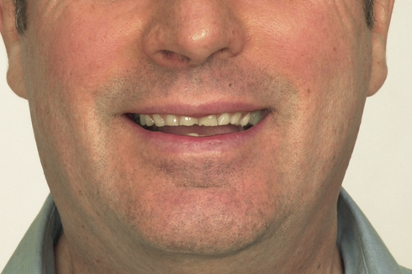
Removable onlay/overlay prostheses
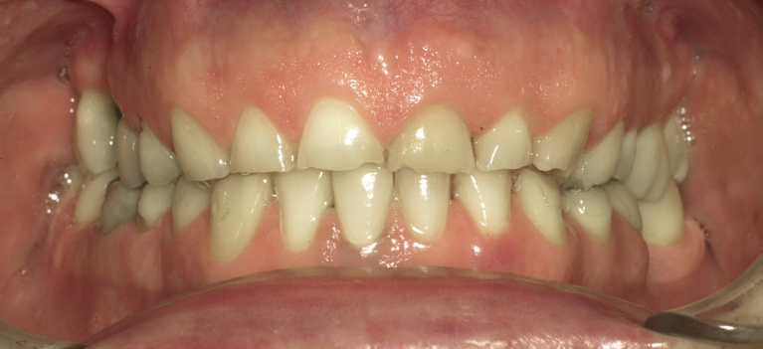
The use of a removable onlay/overlay prosthesis can be a valuable means of rehabilitating patients with moderate/severe tooth wear, particularly when there are also missing strategic teeth to be replaced. This form of treatment has been advocated by a number of clinicians for patients with more severe forms of tooth wear [17-20]. This approach provides a relatively simple, non-invasive and cost-effective way to achieve improvements in appearance and function of the dentition. Figures 1 and 2 show a patient with significant wear, he has limited means to pay for a full mouth reconstruction, and desires help to look better and become more socially acceptable.
Fig 2 Close up of the wear for our patient
Fig 1 Patient with significant wear to all teeth
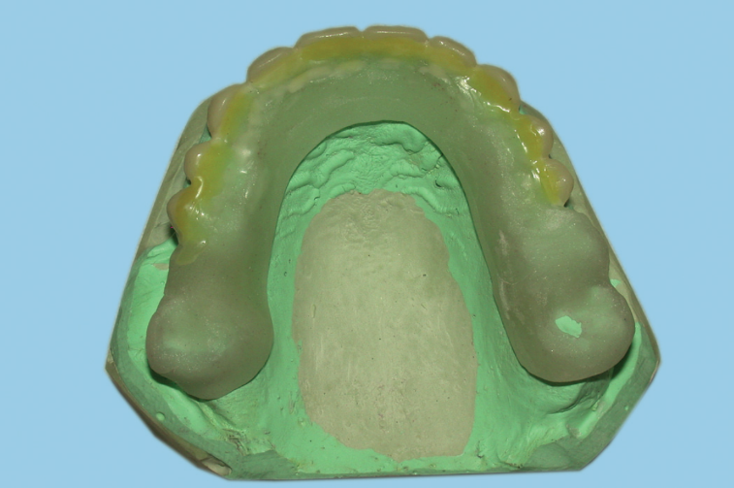
The construction of a provisional acrylic resin removable prosthesis is recommended initially, allowing the opportunity to carry out modifications to the shape, position and occlusal relationship of the prosthetic teeth and soft tissues, as well as assessing the patient's tolerance of a removable prosthesis. It is advisable to avoid any significant tooth preparation at this stage other than rounding of sharp
Fig 3 an all acrylic resin prosthesis is fabricated to check
The patient’s ability to tolerate a change in VDO.
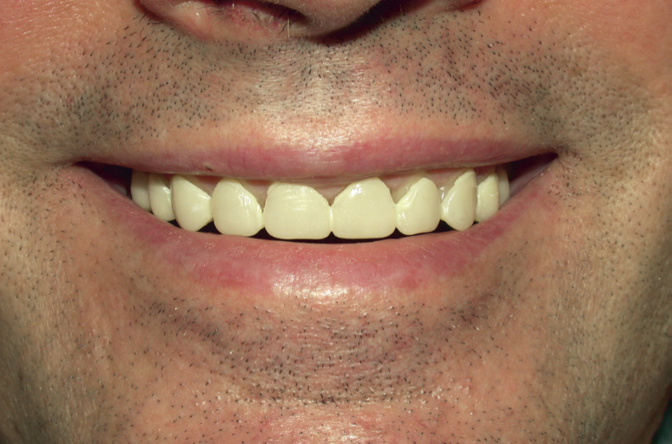
edges , but if this treatment approach is to be continued in the longer term as a cobalt-chromium framework, some tooth preparation in order to optimize appearance, fit and retention will be required. Space demands can be greatest in the anterior region, both in the vertical and labio-lingual dimensions, and will be influenced by the amount of sound tooth structure remaining and changes to the occlusal vertical dimension.
Fig 4 teeth have been added to the all acrylic resin prosthesis to aid in the patient’s acceptance of the changes in esthetics and function.
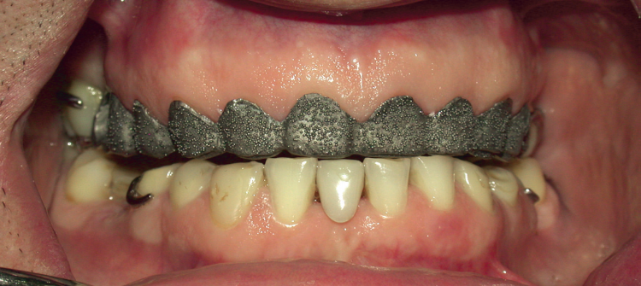
Photos show the use of an acrylic resin appliance to evaluate the patient’s ability to tolerate a 2mm change in the vertical dimension of occlusion and the esthetic changes for the anterior teeth. The use of a metal framework is necessary for long term function of the appliance. A one millimeter thick appliance over the
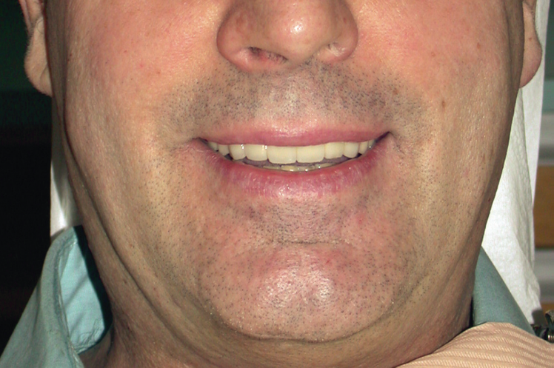
framework is tried in, note the beads in the framework for retention, then the framework is veneered with acrylic resin.
Fig 5 the try in of the metal framework.

While for certain situations this form of treatment offers a satisfactory way of restoring the worn dentition, for many
Fig 6 the patient wearing the new appliance. This is
a successful case with a pleased patient.

patients’ difficulties arise in adapting both functionally and psychologically to a removable prosthesis.
Thanks to Dr. Sara A. Alfadda for the photographs.

Modern Restorative Materials
Gold
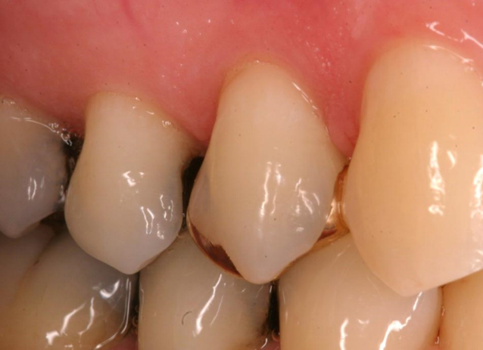
This partial veneer gold crown has been in the mouth for 51 years and was completed by the author. It has restored the function for the patient without any need for adjustment or alteration.
Donavan reports 94.1% at 40+ years as a success rate for gold partial veneer crowns(21). Although it is well known that gold
Fig 7 this partial veneer gold crown was done by the fist author 51 years ago.
is a superior restoration, patients today will shy away from the use primarily for esthetic reasons. Dental schools no longer teach partial gold veneer technology. Dental laboratories report less than 1 percent of their workload is now with gold usage. Patients much prefer the use of tooth colored restorative materials(24).
Gold was the standard of care for many years and has stood up to the test of time.
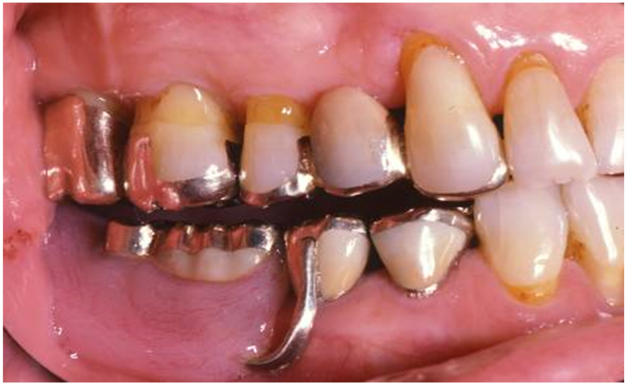
Fig 8 a full mouth case completed with gold full veneer and partial veneer crowns completed by the first author. The RPD framework is gold as is the occlusal surfaces of the denture teeth.
Porcelain fused to metal (PFM)
Fig 8 a full mouth cases restored with gold, the mandibular RPD is a gold framework, and the denture teeth are gold. This much gold display is not appreciated by most patients.
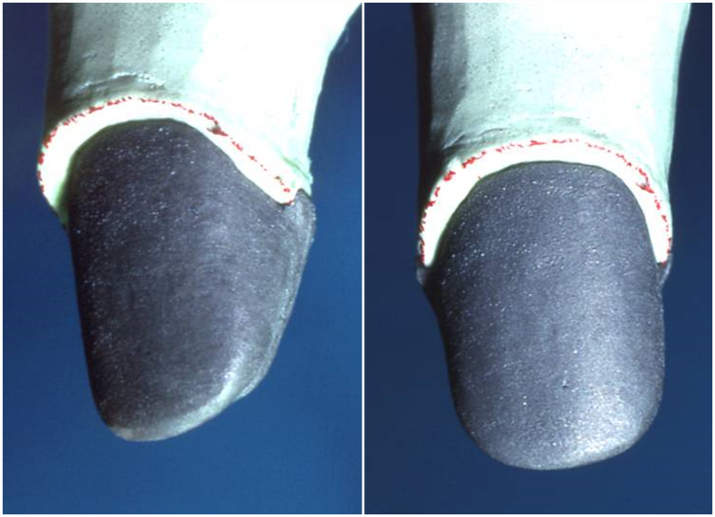
PFM technology has been used for many years. Coornaert reports properly designed, well-fitting, well-stacked, carefully fired ceramometal units have a 10 year failure rate as low as 3%. As a result, PFMs have been exceedingly popular for many years. Dental laboratories have reported a decrease in the use of PFM technology. Glidewell Dental Laboratory reports that only 5% of their incoming workload for crown and bridge work is requested as PFM(24).

Fig 9 the PFM crown will start with the metal having an oxide layer that helps with the porcelain adhering to the metal. This dark almost black substructure must be blocked out for esthetics.

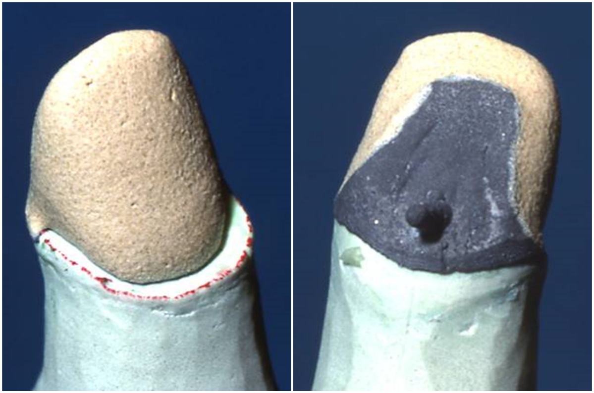
A PFM crown will have a metal substructure which must be opaqued to prevent the dark metal from showing. Feldspathic porcelain can then be added to give translucency and color to the new crown. The metal and the opaque layers take up considerable space in the new crown, requiring significant tooth reduction to accommodate the required materials.

Fig 10 a heavy layer of opaque feldspathic porcelain must be placed on the coping to hide the dark color. This is referred to as an opaque layer and can take up to .2 or .3 mm of space. The need for coverage of the dark metal requires more tooth reduction to create space for the layers of porcelain required for esthetics.

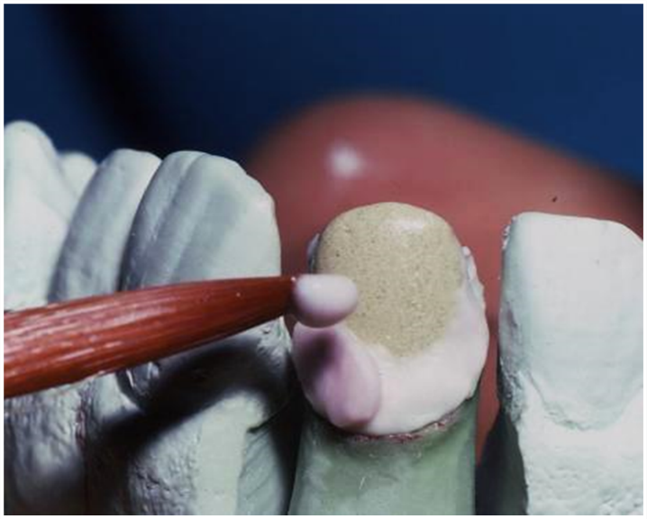
Feldspathic porcelain is layered over the opaque to provide translucency and color. The feldspathic porcelain is used as a powder, then layered on the substructure. Feldspathic porcelain will contain quartz particles which can cause wear to the opposing dentition. Quartz particles are present for the proper coefficient of expansion, to provide strength and crack resistance, and to aid in color.

Fig 11 Felspathic porcelains are layered onto the coping to provide color and translucency for maximum esthetics.
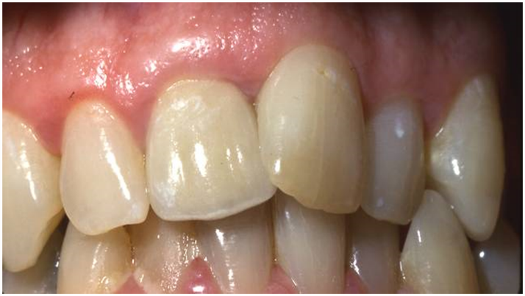
Fig 12 shows the final restoration in place #9. Please note how it mimics the colors of both the lateral and the central incisor. Customization of the felspathic porcelain for the individual patient is an advantage for the patient.
Fig 12 shows the PFM crown on tooth #9. Note the slight translucency at the incisal edge, and the variety of colors imbedded into the crown to attempt to mimic the natural dentition. Porcleain work was completed by the first author.

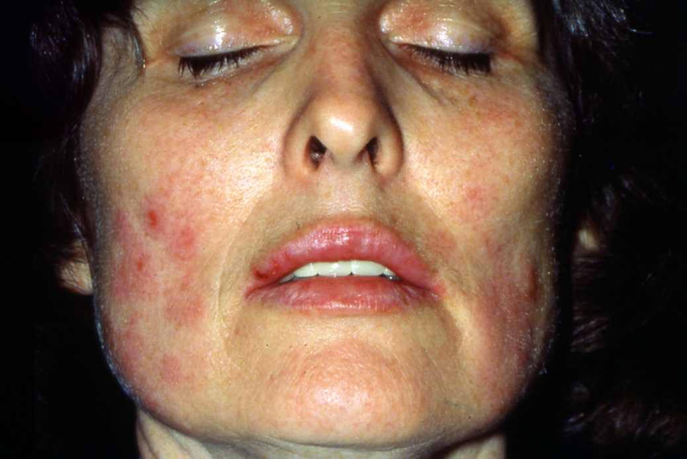
Figure 13 is a photo of a patient who had a non-precious crown inserted. Within an hour she had edema, and ulcerations occur. She was admitted to the ICU and given large doses of steroids. The use of non-precious metals should be discouraged.
PFMs usage has decreased due to cost, and the need for excessive tooth structure reduction. The metal of choice is palladium which the price has risen significantly in the market. Labor time to cast and stack the porcelain has also risen. Joshi showed blood levels of Ni had crossed the limits of the clinically considered toxic level at 12 months, which is a concern that requires further long term investigation. The use of non-precious metal is discouraged due to allergic problems(22,23).
Fig 13 shows a patient two days after the insertion of a non precious crown.
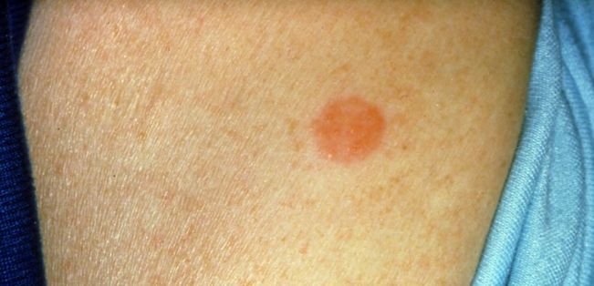
The patient was tested for allergy to the metal used in the crown fabrication. After only 5 minutes of contact with the skin the red area was formed, became edematous and uncomfortable for the patient.

Fig 14 shows where a small ingot of the casting metal was placed by her physician to check on the diagnosis of allergy to the metal.
Difficulty in the removal of the crowns in fig 13 was considerable. No metal could be risked entering the patient’s mouth during the removal process, a rubber dam was placed and a nasal canula used to prevent accidental exposure to the metal fragments or dust.
Empress
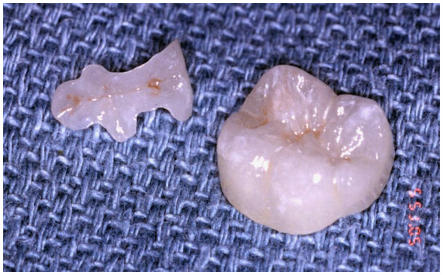
Empress is a Leucite-reinforced all-ceramic material. Used for many years, this material could be bonded to the tooth structure. Extra space must be created for Empress to prevent fracture. Once the inlay or onlay is pressed, the restoration can be stained and glazed conventionally, then etched and bonded into place.
Fig 15 Empress pressings, inlay and onlay ready for insertion.
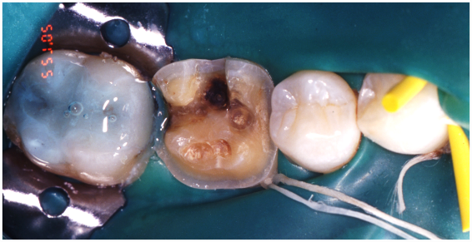
The Empress inlay and onlay are bonded to the tooth structure with a rubber dam in place to prevent moisture contamination.
Fig 16 shows the inlay and onlay inserted using a rubber day to prevent moisture contamination. The onlay preparation is ligated to insure proper isolation.
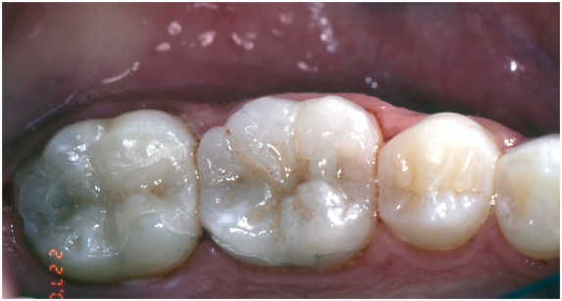
The new empress restorations bonded in place.

Fig 17 shows the new inlay and onlay restorations bonded in place. Photo was taken several days after insertion.

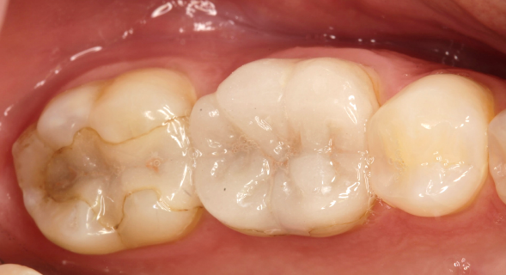
Fig 18 shows the Empress restorations now in place for 27 years. There are some discolorations of the luting cement, there are no caries, but it has been successful for 27 years. The use of empress as a restorative material is very successful.
Fig 18 shows the same restorations in place for 27 years.
Zirconia
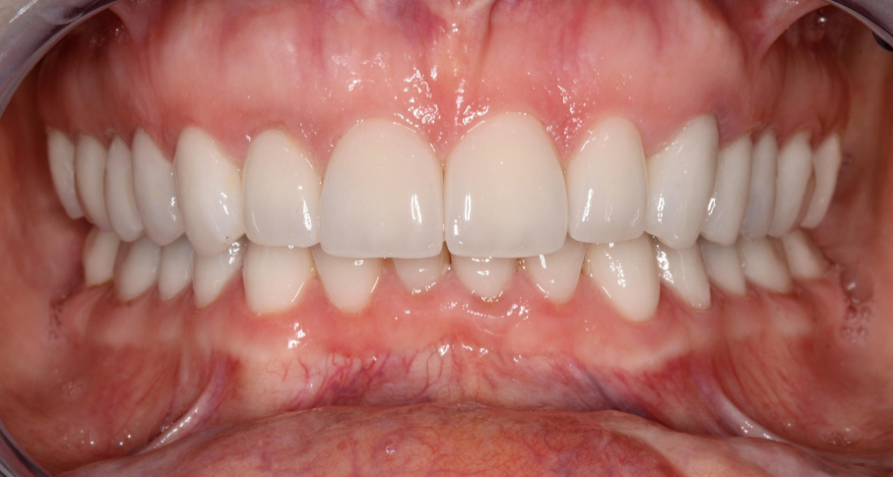
Zirconia substructures with feldspathic porcelain overlay. The advantage for the patient is less tooth structure reduction is required, esthetics are optimal with layered porcelain producing a depth of color and translucency for a natural appearance.
Fig 19 shows a full mouth completed with zirconia substructures and feldspathic porcelain layers. Note the variety of color and the translucency of the material. Optimum esthics are possible with this system and reduced tooth structure is required as compared to the PFM.

Zirconia is a crystalline material with superior strength. Made from zirconia oxide, the material is pressed into a block which can be milled, then heated in a furnace to complete the ceraming process. Blocks are made using a cold isostatic pressing. Zirconia powders are placed in a deformable mold then using external pressure pressed into shape. Called “green” blocks. With a flexural strength of 1150 MPa, zirconia is extremely strong. Glidewell dental laboratory reports that Zirconia is currently the most popular material for crowns in 2024(24,25).
Layered zirconia 2.2 %
Bruxzir 65.9%
Bruxzir esthetic 17.8%
Emax 6.8%
PFM 5.7%
Advantages of zirconia are:
-Less coping thickness required allows for more translucency – can go as thin as 0.3mm for anterior restorations
-Reduced coping thickness allows for more room for esthetic veneering
-Shaded copings assist ceramist to achieve better esthetics, allowing a thinner coping and a need for less tooth structure reduction.
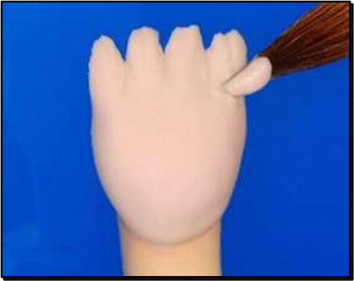
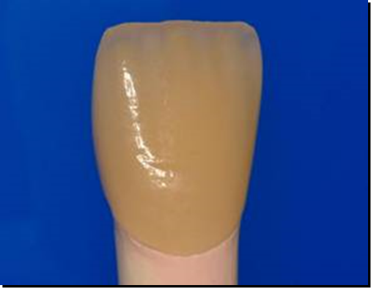
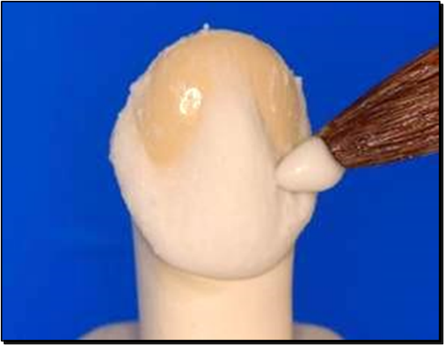
Figures 20,21,22 show the development of a zirconia substructure with feldspathic porcelain layered. Note there is not black metal substructure, and the need for a heavy opaque layer is not present. Less tooth structure removal is not required. The substructure is tooth colored, and the technician can layer the porcelain directly on the substructure. Alternating layers of body porcelain and incisal porcelain will create a beautiful crown.

By using a combination of opaque and translucent porcelains and adding color stain between the lobes, a very natural looking crown can be created. The same combination of porcelains can be used to give a natural appearance to PFMs, but more tooth structure reduction is required.
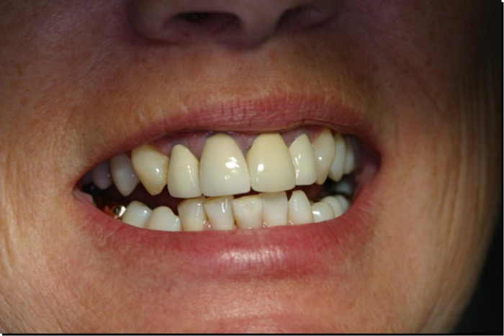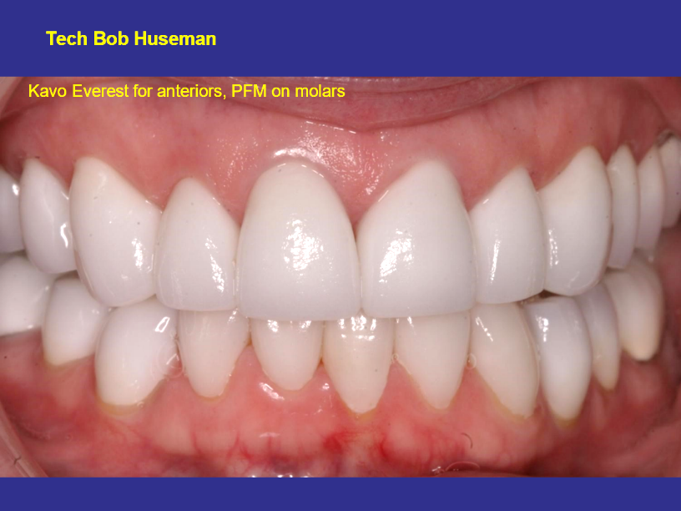
Fig 24 The same case as fig23, the patient requested a high value color. The crowns have been in place for this photo for 16 years.
Fig 23 Patient is not pleased with the PFM opacity
To her crowns. She requests a change.

The photos in figures 23 and 24 show the original PFMs which had become unsightly to the patient. PFMs can be very opaque if there is not sufficient tooth reduction to insure enough space for the metal, opaque, and feldspathic porcelain. The PFMs for this case were replaced using all ceramic zirconia restorations with feldspathic porcelain veneered on the zirconia substructures. This case is now 16 years old. Some natural recession has occurred, but the color and form have remained unchanged. The use of zirconia for crowns has been an exciting advancement for our profession. The combination of metal-like strength and exceptional esthetics, combined with the longevity of metal, and the need for less tooth structure reduction makes this an excellent restorative material.

Zirconia crowns can be made of pure zirconia, which has exceptional strength, or can be used as a zirconia substructure with layered feldspathic porcelain. If the pure zirconia is used alone, the resulting crowns will be very strong, but can be opaque with little translucency.

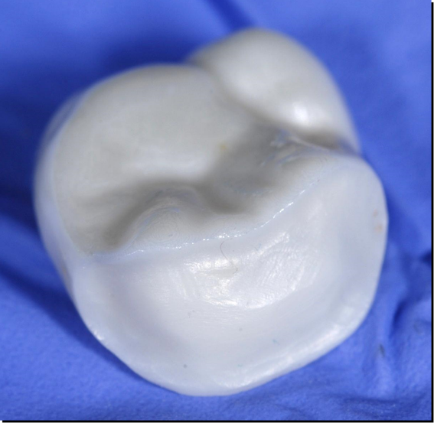

Fig 25 shows the typical use of zirconia on the occlusal surface for strength and to allow the placement of feldspathic porcelain on the facial surface. Less tooth structure removal compared to a PFM is required for a zirconia crown.
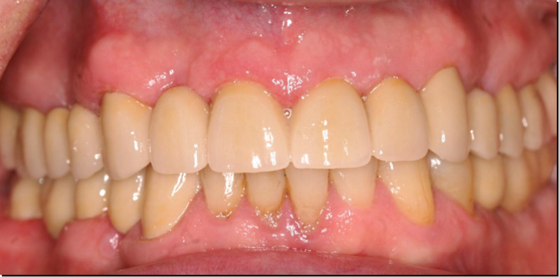
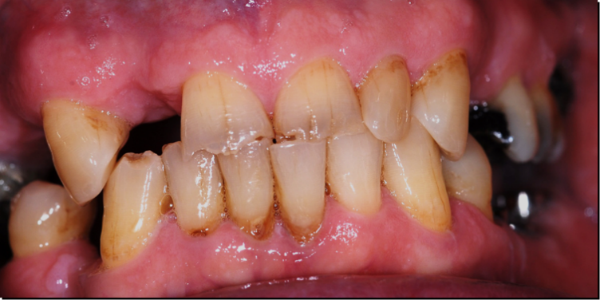
Fig 26 and 27. A 72 year old patient who demands fixed restorations and great esthetics. This case was completed using substructures as shown in fig 25 on all posterior teeth. The anterior teeth are also zirconia with feldspathic porcelain layered for esthetics. Vertical was opened by 1mm, the case was done in provisionals first to insure a successful completion.

The photos in figs 26 and 27show a zirconia case where the vertical dimension of occlusion was
opened by 1mm at the anterior teeth. To protect the feldspathic porcelain from forces of occlusion the use of zirconia on the occlusal surface of the tooth with feldspathic porcelain layered into the esthetic portions of the crown will protect the feldspathic porcelain from fracture.

The photo in fig 25 reflects the design of the zirconia with a window for the feldspathic porcelain. This is a substructure for the case in figs 26 and 27. Patient demands for longevity
and great esthetics drives how we approach many of these cases.
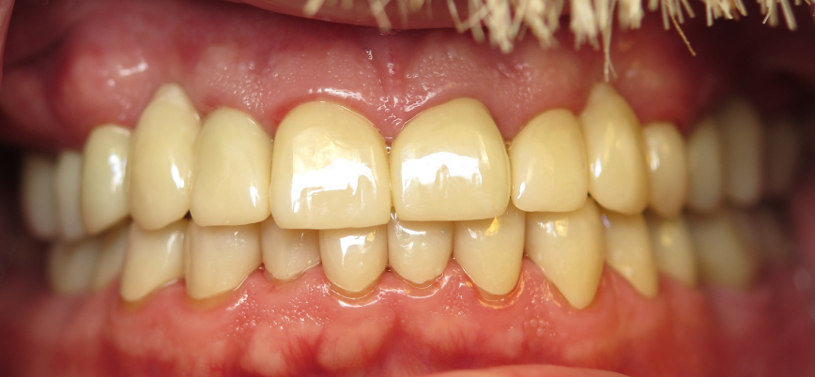
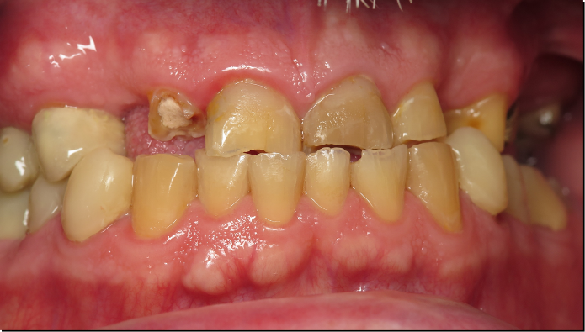
Figs 28 and 29 this patient requested crowns that gave the greatest strength, and was not concerned about esthetics. Note the missing cuspids for the patient. The use of pure zirconia was completed on this case, no feldspathic porcelain was layered onto the substructures.

The above figs 28 and 29 is a pure zirconia restored case. There is no layering of feldspathic porcelains on the zirconia. There is little translucency, but the color is acceptable, and the patient requested a restorative material which had the least chance of fracture. This was a challenging case since the cuspids were missing. The vertical dimension of occlusion was raised 1.5mm at the incisal edge, individual provisional restorations were made indirectly for this case to insure the patient could tolerate the change in VDO.

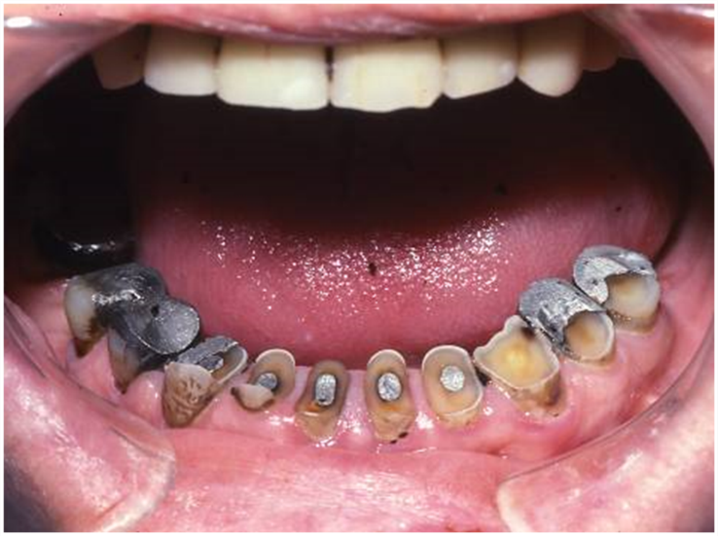
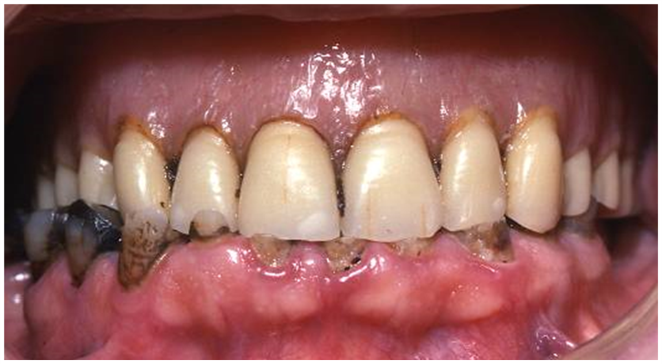
Figs 30 and 31 show the effects of feldspathic porcelain against natural teeth. Once the glaze is broken, quartz particles are exposed which are extremely abrasive.

The photos in figs 30 and 31 show the effect of feldspathic porcelain denture teeth against natural teeth. Feldspathic porcelain contains quartz particles suspended in a glassy matrix. Once the quartz particles are exposed and allowed to contact natural tooth structure, wear will occur. Studies have shown that zirconia, which is a crystalline structure, will not show the wear that feldspathic porcelain will. Hardness of the material is not an indicator of abrasiveness, but the surface texture is important in abrasion of the opposing dentition
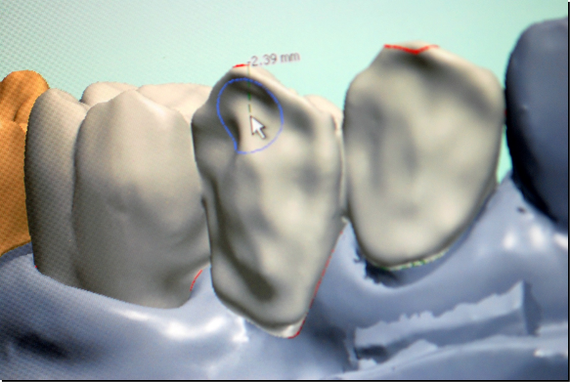
The zirconia substructure can be designed with the incisal edge in zirconia, this will allow all forces on the very strong zirconia and not on the more abrasive and weaker feldspathic porcelain.

Fig 32 shows the design of anterior teeth where there could be a possibility of abrasion to the opposing dentition. Bringing the zirconia to cover the incisal edge will prevent contact with the felspathic porcelain layering the zirconia coping.

The zirconia substructures in fig. 33 have pure zirconia over the incisal edge, still allowing feldspathic porcelain to be baked on the body of the crown for esthetics. Having pure zirconia over the incisal edge will aid in the prevention of fracture of the veneering porcelain as well as protecting the opposing dentition from contact with the more abrasive feldspathic porcelain.
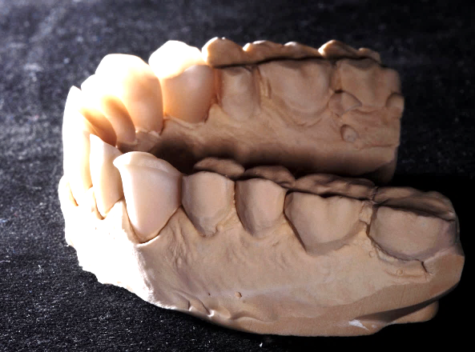

Fig 33 showing the zirconia substructures which prevent feldspathic porcelain from coming into contact with natural teeth.
Zirconia has shown itself to be very successful in the mouth. Pihlaja shows a 100% survival rate over a 4.9 year time period(29). Using a design which only allows occlusal contact with the pure zirconia and avoids contact with feldspathic layering porcelain will insure a long and happy lifetime for the restoration.

Lithium Disilicate
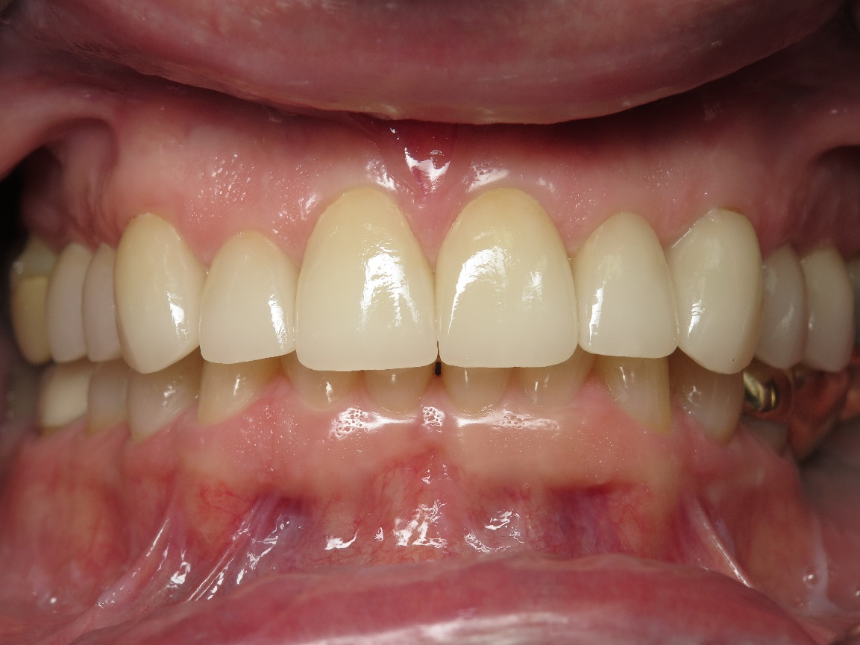

Fig 34 showing lithium disilicate crowns on teeth 4-13. These have been in place for 4 years.

Lithium disilicate is a glass, an all ceramic system. It is also referred to as eMax. It can be used as a substructure and have feldspathic porcelain layered onto it or used as a milled or pressed unit. It can be ideal for single units, the translucency of the structure allows better light transmission , and beautiful esthetics. It is an essential material for modern dentistry with superior esthetics, high strength, and ease of fabrication. Most eMax crowns can be supplied in four levels of translucency, high, medium, low and medium opacity. Surface staining can be used or the use of shaded cements can help the clinician with color modification. The strength of eMax is high, with a biaxial flexible strength of 360 MPa for milled, and 400 MPa for pressed crowns(26).

Luting the new crowns
Luting cements are usually resin-based and used in combination with the manufacturer's dentine bonding agent where appropriate.
Provisional Restorations
The authors recommend for extensive cases that the work be completed in provisionals first, only after the clinician is confident that the patient is satisfied with the esthetics and the function, should the patient be completed using restorations of choice(27).
Direct in the mouth
For single units and select multiple unit cases, the simplicity of using a direct in the mouth fabrication technique is expected. The use of a Bis Acryl material will not generate excessive heat, and will complete polymerization quickly in the mouth. The material is difficult to add to and is softer and rougher in the mouth. It can be brittle and fracture.
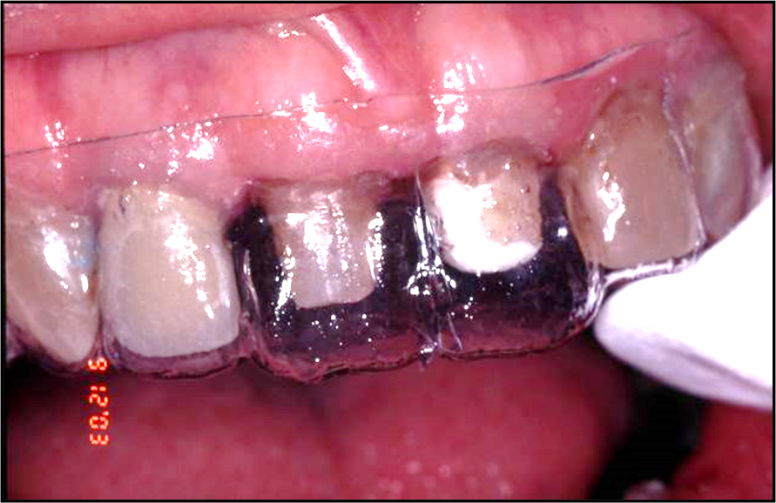

Fig 35 shows the use of the vacuum formed matrix direct in the mouth. The matrix is filled with the bis-acryl material and allowed to set. It can then be removed and trimmed to fit the required contours.
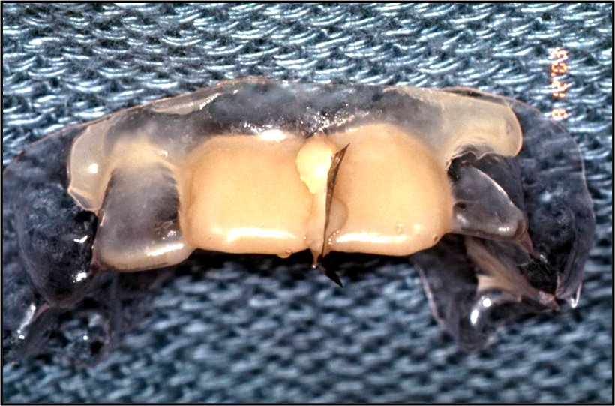
In fig 36 a matrix band has been cut and placed interproximal. This allows separation of the provisional crowns and allows the patient to floss and clean the provisional crowns.
Fig 36 shows the direct matrix removed from the mouth and ready to trim and fit.

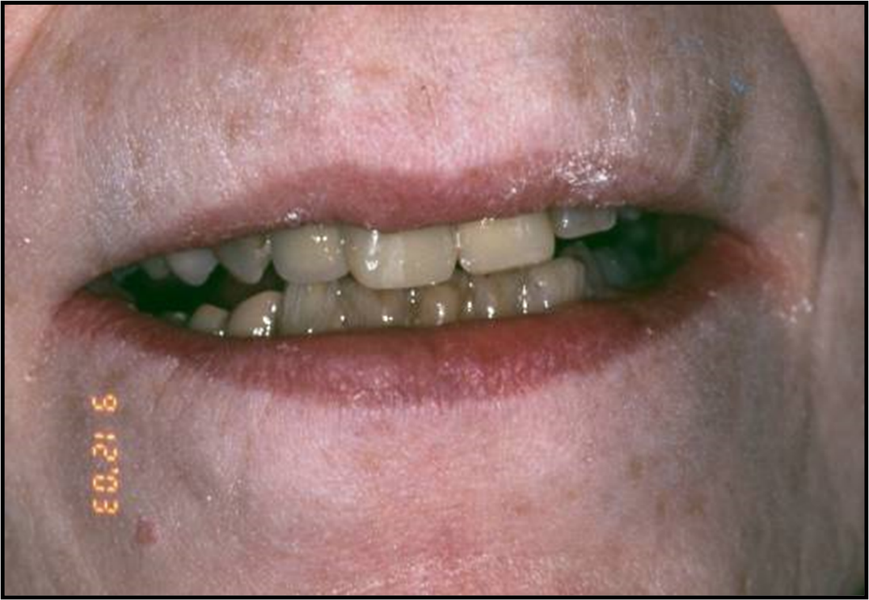
Provisionals are present for teeth 8,9 following direct fabrication in the mouth(27).

Fig 37 direct provisionals inserted.

Indirect provisionals
The author recommends the use of indirect provisionals for the fabrication of provisionals which will have to be in the mouth for an extended period, and esthetics are critical(28). Making indirect provisionals allows the clinician to make individual provisional crowns for up to a full mouth restoration. The patient can wear these for months, the patient can clean them as normal, and it will allow the clinician to evaluate the esthetic changes and any occlusal changes that may have been done. The provisionals are made from methyl methacrylate and polymerized under heat and pressure chairside. This produces a dense, strong, color stable, and highly accurate provisional that is easy to adjust and add to. Making this provisional out of the mouth does not endanger the tooth with exothermic heat produced from the polymerization process, and shrinkage under pressure is toward the cast, and does not create marginal issues.
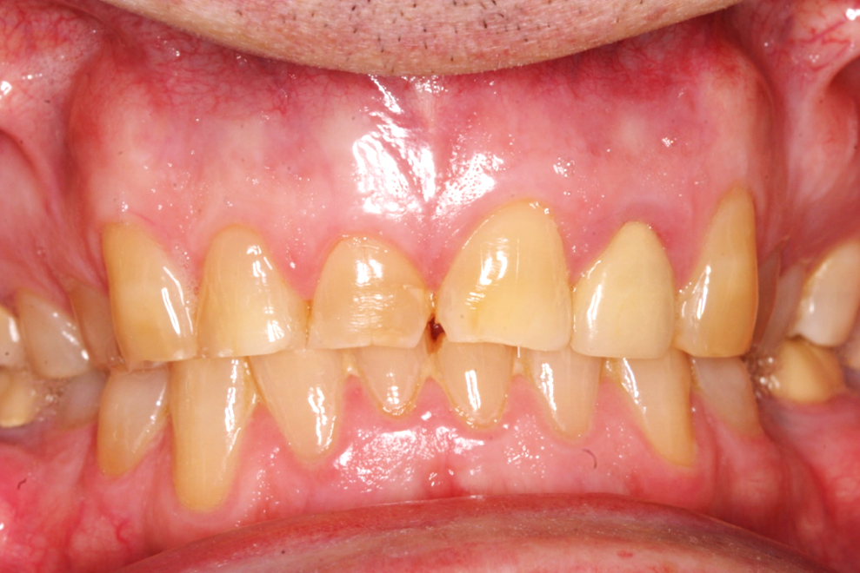
This patient is a 60 year old male, he played professional football and has horizontal bruxism wear to the maxillary anterior teeth. His wife who is a dentist referred him to the first author for new crowns on 6-11.
Fig 38 shows the preoperative photo for the patient referred for crowns 6-11. Note the loss of incisal edge from wear.
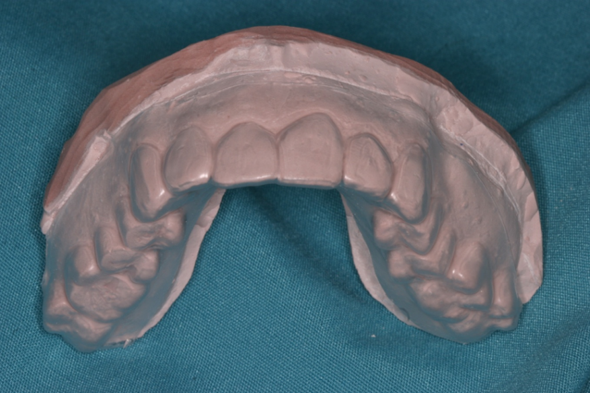
Accurate alginate impressions were made, a wax up completed using standard anatomical contours, the central incisors were lengthened 2mm, the laterals were 0.5 mm shorter and the cuspids were the same length as the centrals.
Fig 39 shows the wax up which has been duplicated into a solid cast, a vacuum formed matrix is made using the wax up for new contours.
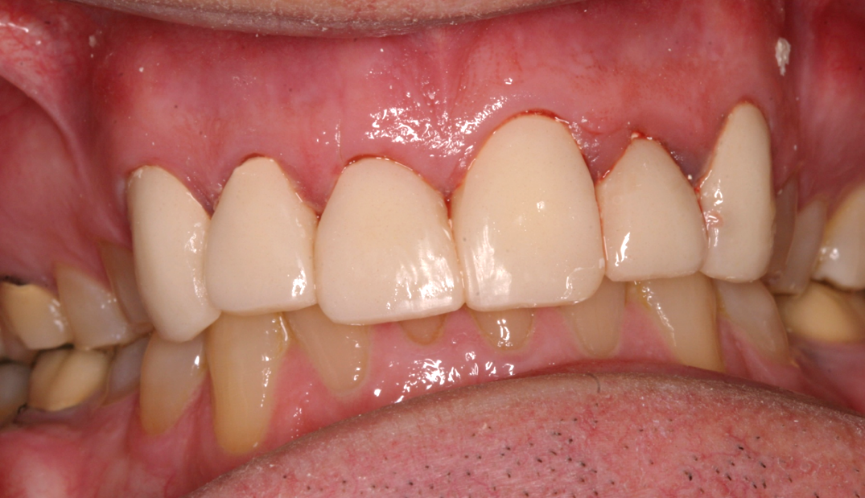
The indirect provisionals are made according to the process in Hansen et.al. The new provisionals were luted with a zinc oxide and eugenol cement. The patient was sent home. Within minutes the wife called objecting to the appearance of the provisionals. The wife, also a dentist, stated she hated the shape of the teeth, and stated it made the patient look like “an old picket fence”. She sent a photo of the patient during his playing days and requested a remake of the provisionals.

Fig 40 shows the indirect provisionals as placed at the time of preparation.
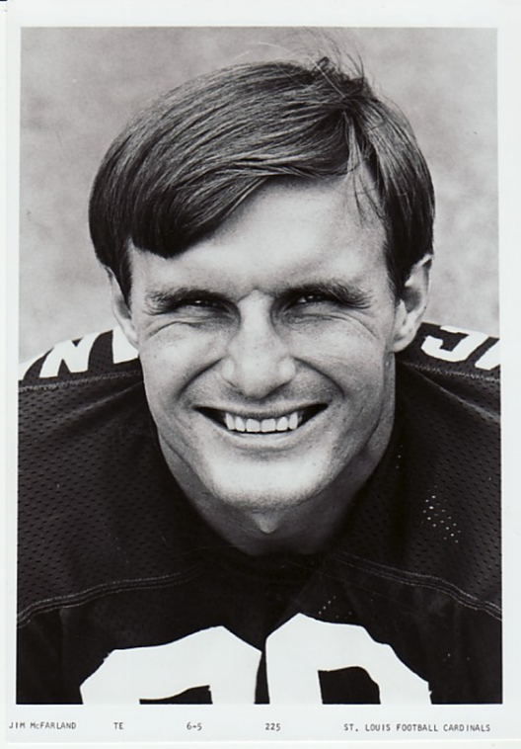
Fig 41 revealed maxillary anterior teeth all the same length, the laterals were added to, and the centrals and cuspids reduced in length to the satisfaction of the patient and his wife. Since the provisionals were methyl methacrylate it was easy to add new material, and the final restorations polished. The provisionals did not have to be remade.

Fig 41 is the patient photo as an NFL player. Note the anterior teeth are all even across the front.
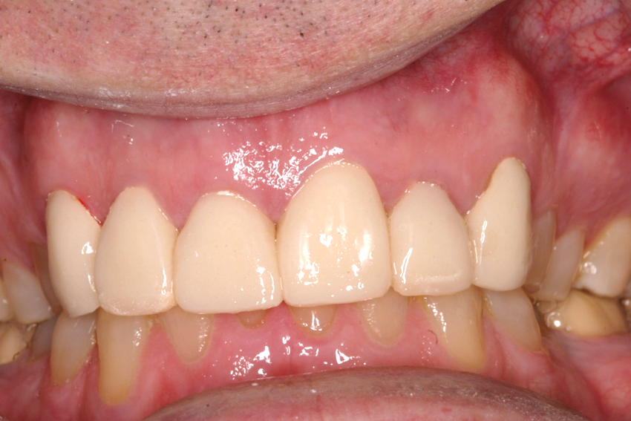
Fig 42 the provisionals have been modified by shortening the central incisors and adding to the lateral incisors.
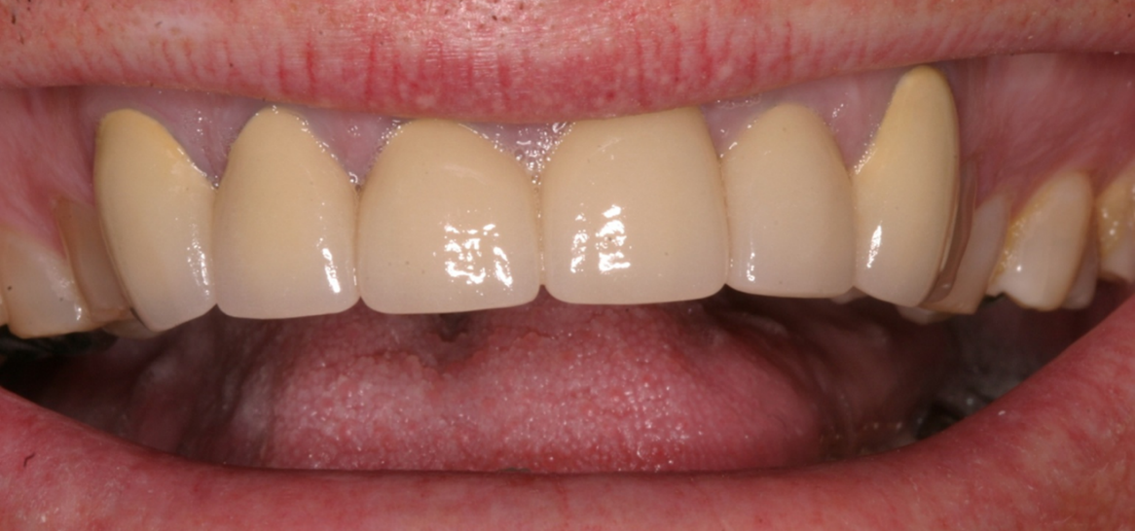

Fig 43 shows the final insertion for 6-11. These are PFM crowns. The new crowns now mimic the contours that were established in the provisionals.
Following the adjustment of the provisionals and the approval of the patient and his wife, an alginate impression was made of the provisionals in place and sent to the dental laboratory as a template cast for esthetics and function. The use of the template cast will allow the lab to know the exact desires of the patient and the dentist. Not only have we properly developed the esthetics, but also the disclusion and anterior guidance for our patient. Without the use of the provisionals to determine the patient’s desires, the clinician will risk the chance of a very unhappy patient.
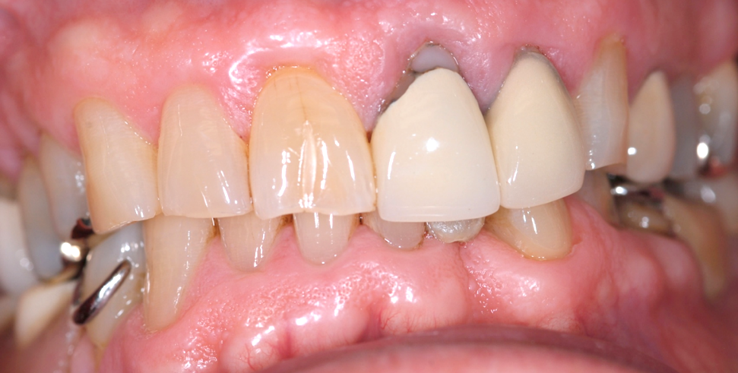
Milled lab fabricated provisionals

Fig 44 is the preoperative photos for a patient requesting a better esthetic outcome and to be able to eliminate the removable partial denture
The first author has found the use of milled provisionals is a great asset for the clinician. The provisionals are made out of methyl methacrylate blocks and milled, or printed. The lab has control of the process and the crown contours. The hardness of the material, and the fine polish allows the patient to wear the provisionals for an extended time period. The provisionals will allow the clinician to evaluate VDO changes, and esthetic changes as requested by the patient. The clinician can use traditional impression techniques or digital scans for the dental laboratory usage.
Patient is a 65 yo male, he and his wife are concerned about esthetics, and they request the RPD be replace by implant restorations. They are very demanding for esthetics. The clinician prepped the teeth and placed implants as needed. Since all teeth were not prepped at the same time, individual provisionals were made at the existing VDO and no change in esthetics.
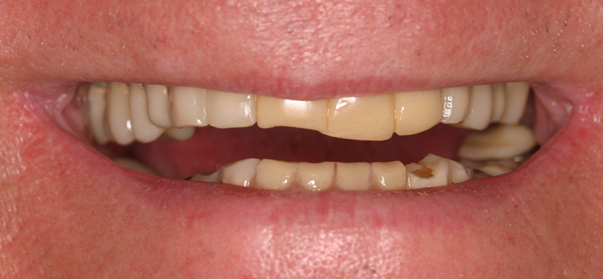

Fig 45 shows bis acryl provisionals made for the patient. The provisionals were made direct in the mouth at the existing VDO.

Bis Acryl provisional restorations are fabricated first, they are shown in fig 45. The direct provisionals are made first as the teeth were prepared in segments and not all at the same appointment. This gives the clinician the ease of using a direct in the mouth material. No change in VDO or esthetics are done at this time. Tooth #9 has been removed, and healing time has been completed. Implants have been placed and time allowed for healing. Traditional impressions were made and sent to the dental laboratory. Lab milled methyl methacrylate provisionals were fabricated and inserted. The VDO was increased by 1.5mm at the incisal edge.
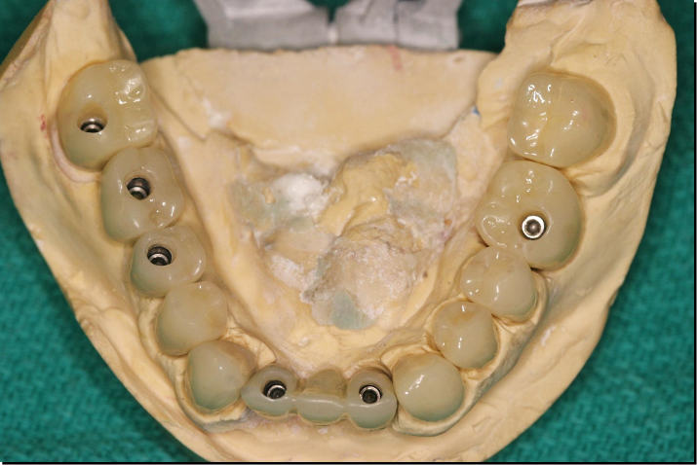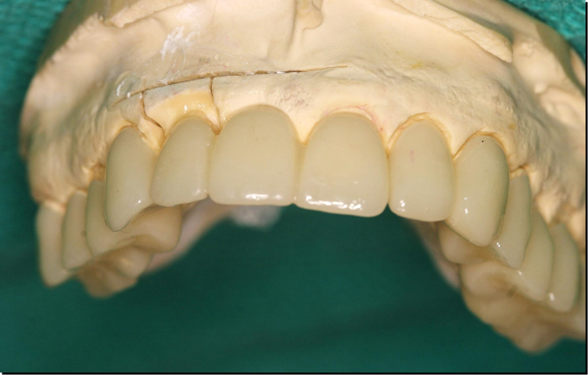
Figs 46 and 47 show the lab milled provisional restorations fabricated by the local dental lab. They reflect the ideal contours we would like to see in the final restorations, and the color of the final crowns. These can be left in the mouth for several months if necessary.
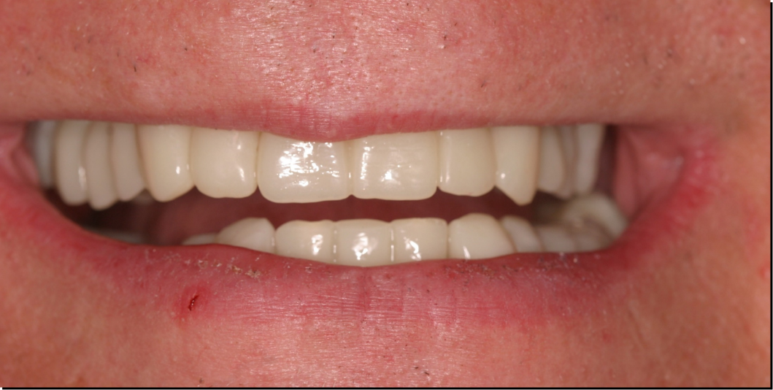

Fig 48 shows the milled provisional crowns in place.
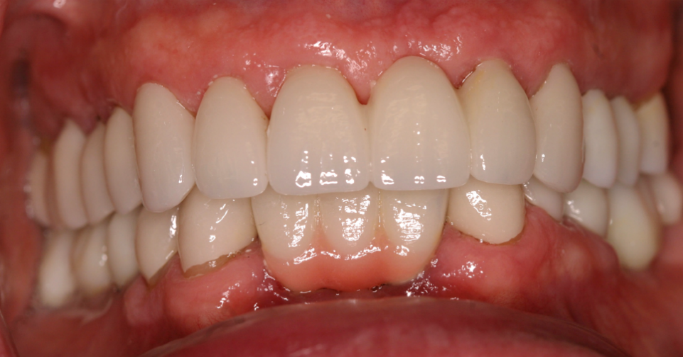
Milled provisionals were inserted and left in place two months prior to fabrication of the final restorations. The patient tolerated the VDO change and the lingual contours that provide us the anterior guidance, both patient and his wife were pleased with the esthetics.
Fig 49 shows the completed case. All are zirconia substructures layered with feldspathic porcelains.
Final restorations seen in fig 49, were made in zirconia and layered with feldspathic porcelain. All functional contacting surfaces were in zirconia.
Mounting the casts
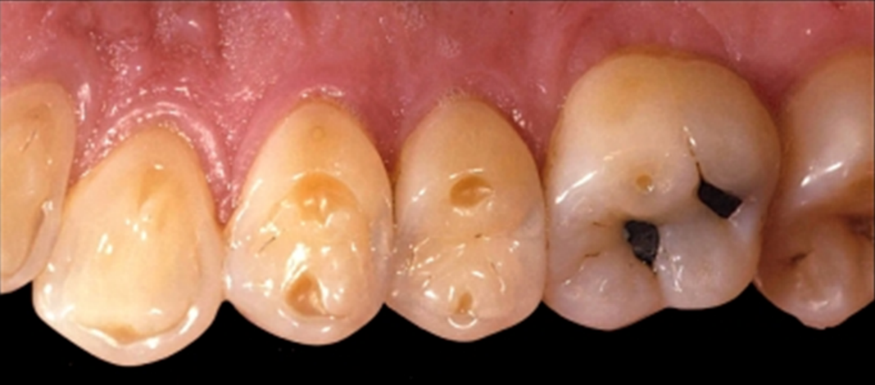
Much of this textbook is dedicated to the diagnosis of erosion cases. Proper diagnosis is essential to the planning for how to treat the patient. The erosion will cause cupping and loss of enamel. These are not wear facets, but the loss of tooth structure though dissolution of enamel, and dentin. It is imperative that the clinician be able to properly look at the loss of tooth structure and treat the patient appropriately.

Fig 50 shows the cupping found in erosion cases.
Typical appearance of posterior teeth with loss of tooth structure due to erosion. Note the cupping in fig 50. To insure we are properly looking at loss of tooth and not tooth to tooth or abrasive loss of tooth, it is imperative that the clinician be able to diagnostically mount the casts made from accurate alginate impressions to insure we are making the correct diagnosis.
Once accurate alginate impressions are made, a facebow registration will allow the maxillary cast to be mounted in the articulator duplicating the position of the cast to the axis of rotation and the Frankfort horizontal plane. Interocclusal records made using a deprogrammer will allow the mandibular cast to be mounted in a centric relation position(29-44).

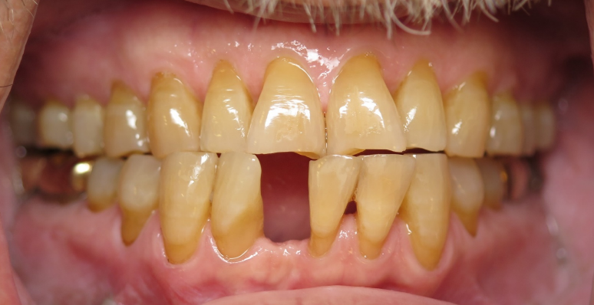

Fig 51 is a 61 year old male, recently lost mandibular lateral incisor, the mandibular incisors have class II mobility.
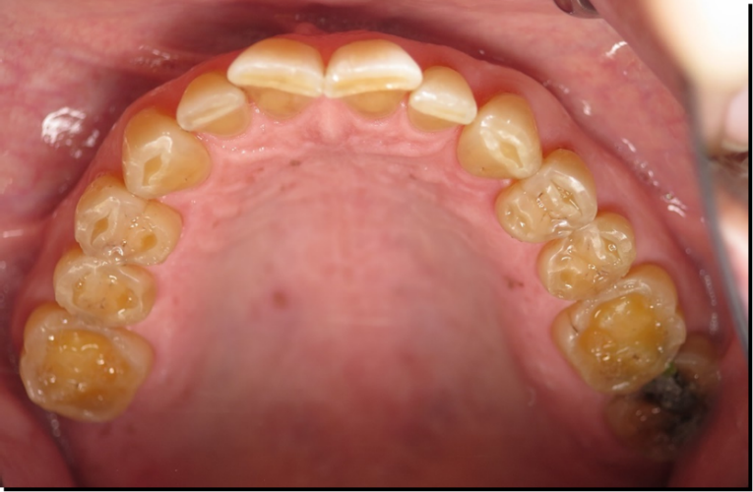
The importance of a mounting cannot be understated. The ability to evaluate the position of the mandibular teeth to the maxillary will provide invaluable information to the clinician(45). The case in fig 51, is a 61 year old male who reported to the dental school with the chief complaint of sharp edges of his teeth causing erosive lesions on his tongue. He was seen three times in 2 years, diagnosed with chronic bruxism and provided with a maxillary acrylic resin orthotic. All of the mandibular anterior teeth had class II or class III mobility and one lateral incisor had been lost. The medical history was positive for acid reflux.
On his fourth visit to the school for the same complaint, a mounting was finally done. A view of his maxillary teeth appears in fig 52. Note the cratering of the posterior teeth.
Figure 52 is an occlusal view of the eroded posterior teeth. Note the cratering present.
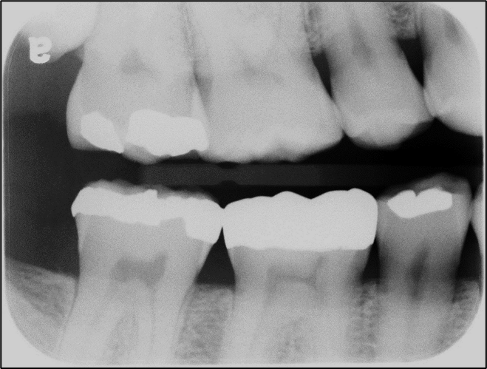
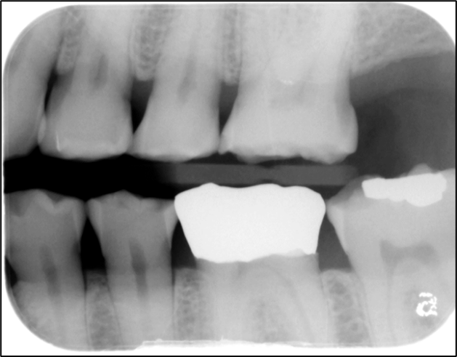

Figures 53 and 54 are original Bite wing radiographs.
Six years have passed between the two sets of radiographs.
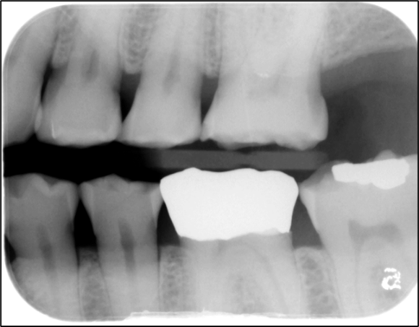
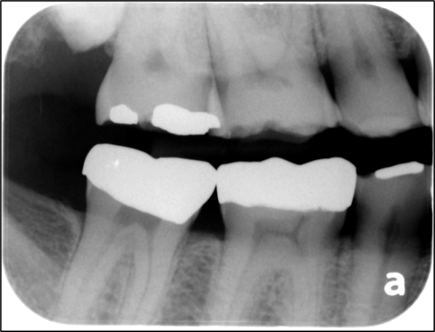
Fig 55 and 56 show the loss of tooth structure on the maxillary posterior teeth.These are taken six years after fig 53 and 54.

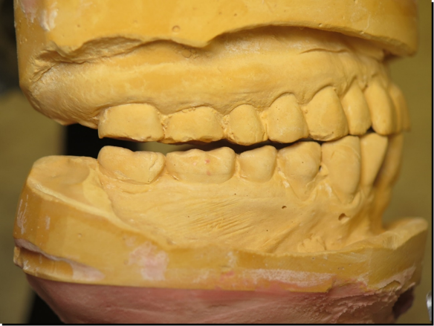
Bite wing radiographs were taken, and reviewed. As compared to radiographs taken six years prior, significant tooth structure was missing from the maxillary arch.

Fig 57 shows the mounting of the max and man casts. Note the lack of occlusal contact on the posterior teeth.
The mounting was done and redone to ensure accuracy. It was compared to his dentition intraorally and determined to be correct. Due to the erosive nature of the stomach acids, the entire occlusal surfaces of the posterior teeth had been lost. The mounting let the clinicians to the correct diagnosis which was erosion and not bruxism. The patient had functioned by protruding his mandible 10 mm in protrusive to obtain enough contact to chew his food. Once the correct diagnosis was made, a wax up was completed, the teeth prepared, indirect provisionals made, and final impressions made. The patient requested gold restorations, and the final restorations were inserted.
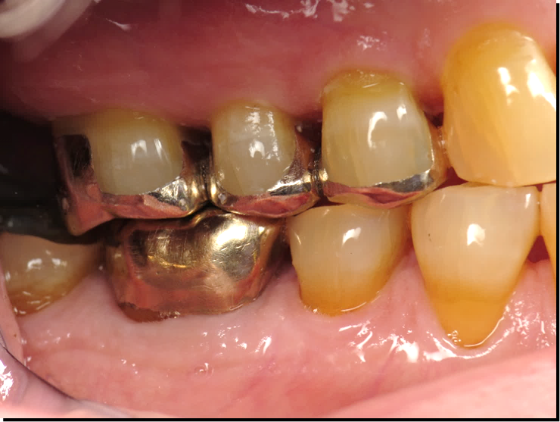b 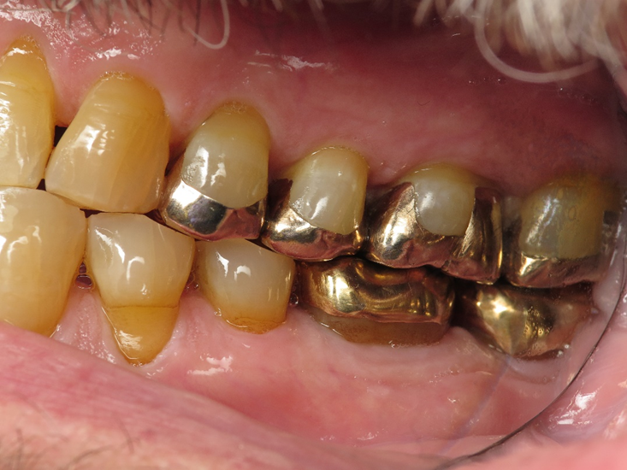
Figs 58 and 59 show the final restorations in place. The patient requested gold as he knew the longevity of gold was superior. The teeth had the occlusal surfaces dissolved by the acid reflux, thus the facial and lingual walls of the teeth were not affected.
Restoration of the case was completed using gold at the patient’s request. Once the posterior occlusion was restored, the mobility of the anterior teeth returned to normal. No mobility in the anterior teeth once the case was completed.
Restoring the difficult cases
Using crown lengthening for restoration of the eroded teeth

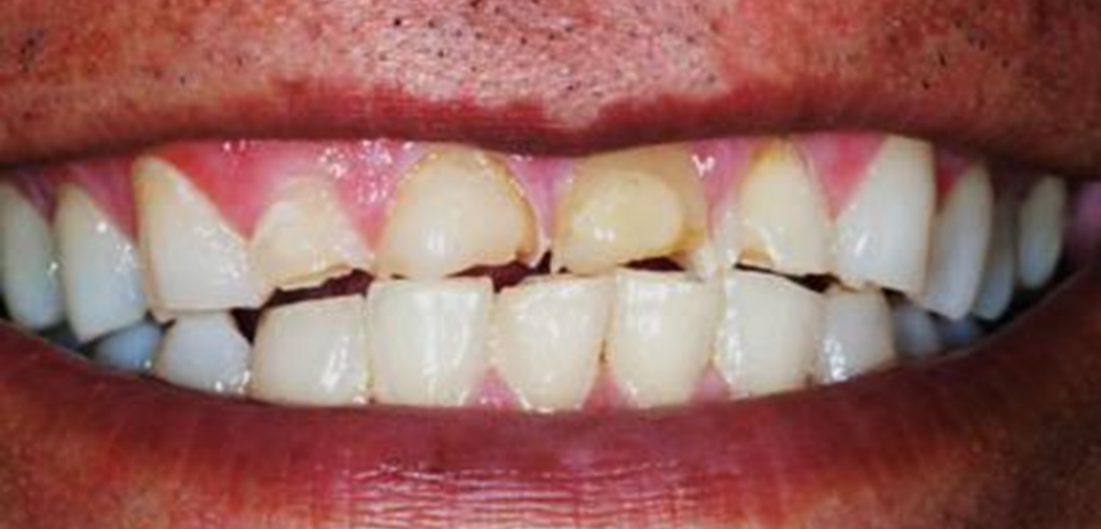

Fig 60 shows the teeth of a patient who enjoyed sucking on lemons. As the teeth dissolved, they continued to erupt. The free gingival margins were significantly below the free gingival margins of two cuspids.

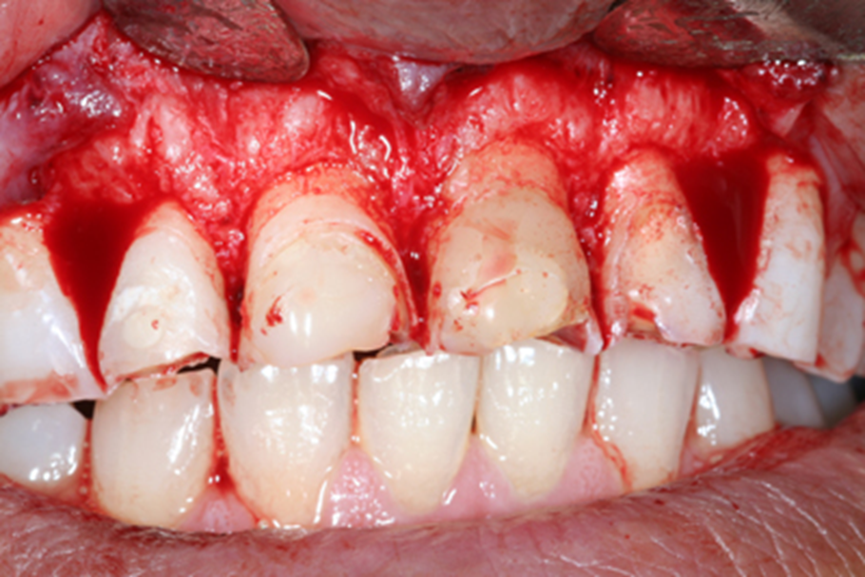
The teeth in fig 60 belong to a 56 yo male who listed the sucking of lemons as part of his dental history. The destruction of the maxillary anterior teeth is due to the acid content in the lemons. Not only do we see loss of tooth structure, but the eruption of the teeth occlusally as the tooth structure is lost. Often the mandibular anterior teeth also continue to erupt. This change of position of the teeth can result in a change in the tissue contours.

Fig 61 shows a flap reflected to expose the osseus tissues. The periodontist recontoured the bone to all the free gingival margin to be relocated apically.
A full flap is reflected, and osseous recontouring is completed. The emergence profile of the tooth is restored, and normal gingival contours are restored. Three to four months of healing is required for the keratinized tissues to return to normal.
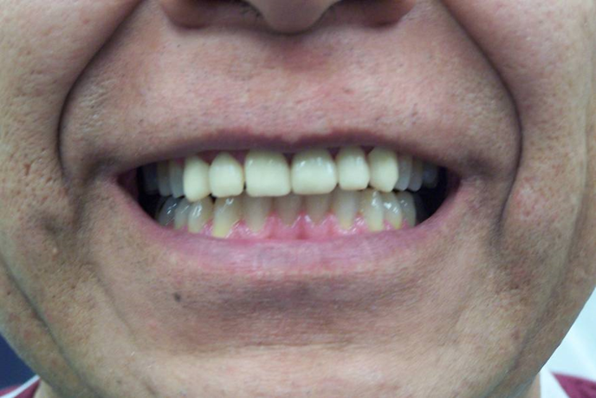

Fig 62 Indirect provisionals were made using a wax up for ideal contours, allowing the clinician to evaluate tissue contours, and esthetics to insure patient satisfaction.
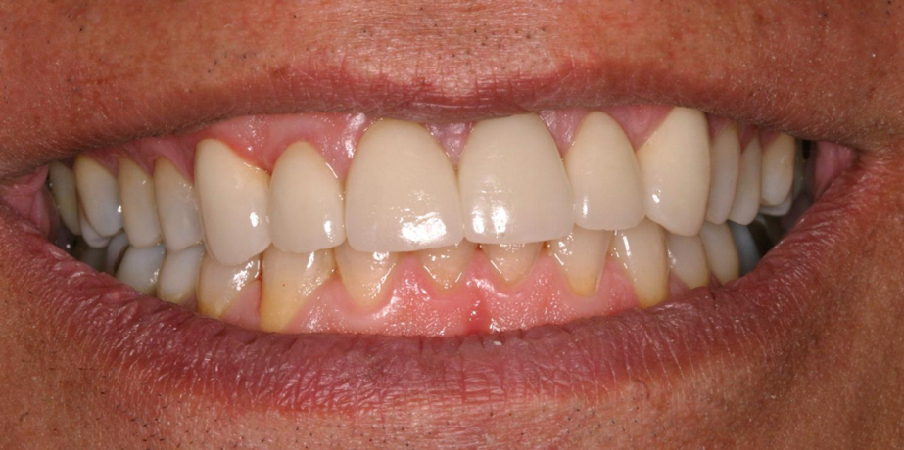

Fig 63, final zirconia restorations were placed following complete healing of the gingival tissues. The smile was completely restored, contours of the crowns and incisal edge length are restored.
Once the provisionals were found to be acceptable to the patient, the final restorations were placed to mimic the provisionals. Six zirconia substructures layered with feldspathic porcelain were inserted(45-50). Patient was very pleased with the result.
Using change of vertical dimension of occlusion for restoration of eroded teeth.

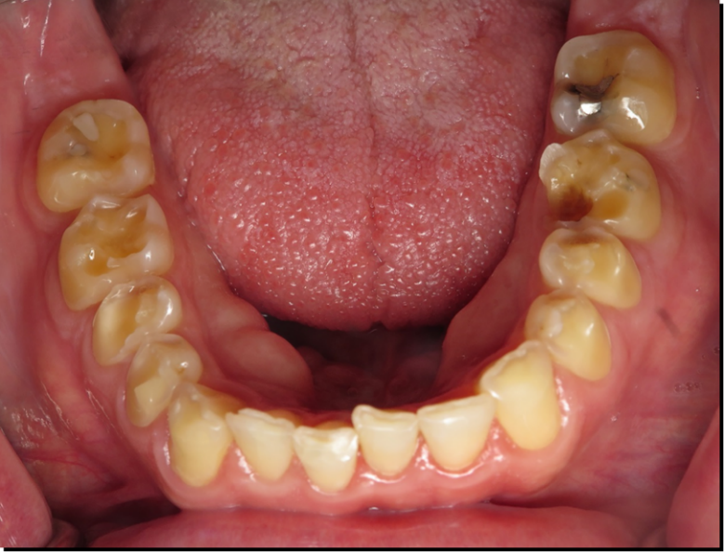

Fig 64 is an occlusal photo of a 41 year old male with gastric reflux. Much of the clinical crown is dissolved in the reflux acids.
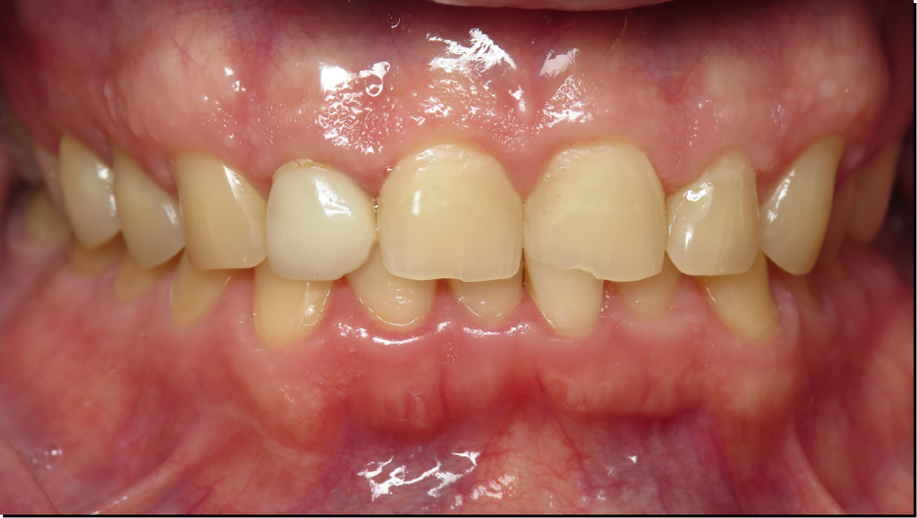

Fig 65 is a frontal photo of our 41 year old patient. He is concerned with the loss of incisal edge length and the loss of tooth structure for posterior teeth.
Patient is a 41 year old male, he has a chief complaint that his teeth are melting away. He has noted in his medical history that he suffers from gastric reflux. He complains of sensitivity to eating, and complains of loss of tooth structure and he is worried about losing his teeth. Clinical exam reveals significant loss of tooth structure for both the anterior and posterior teeth.
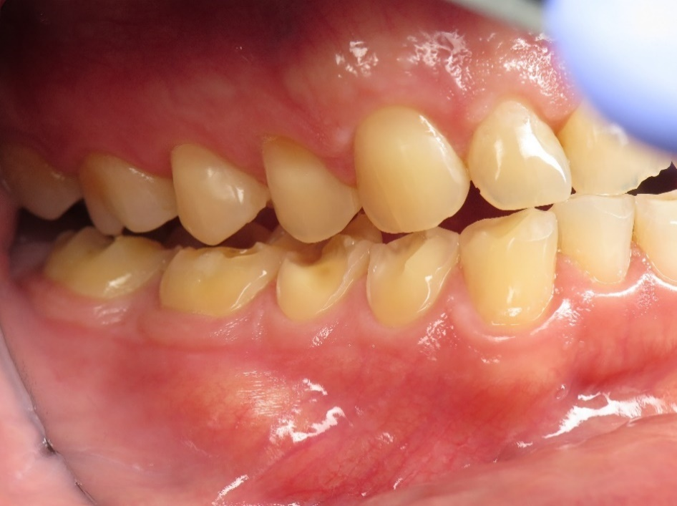

Fig 66 is a buccal photo that reveals loss of tooth structure down to the free gingival margin. Both the left and right sides are affected the same. Often the stomach acid will accumulate in the buccal vestibules and cause erosion of the buccal surfaces.

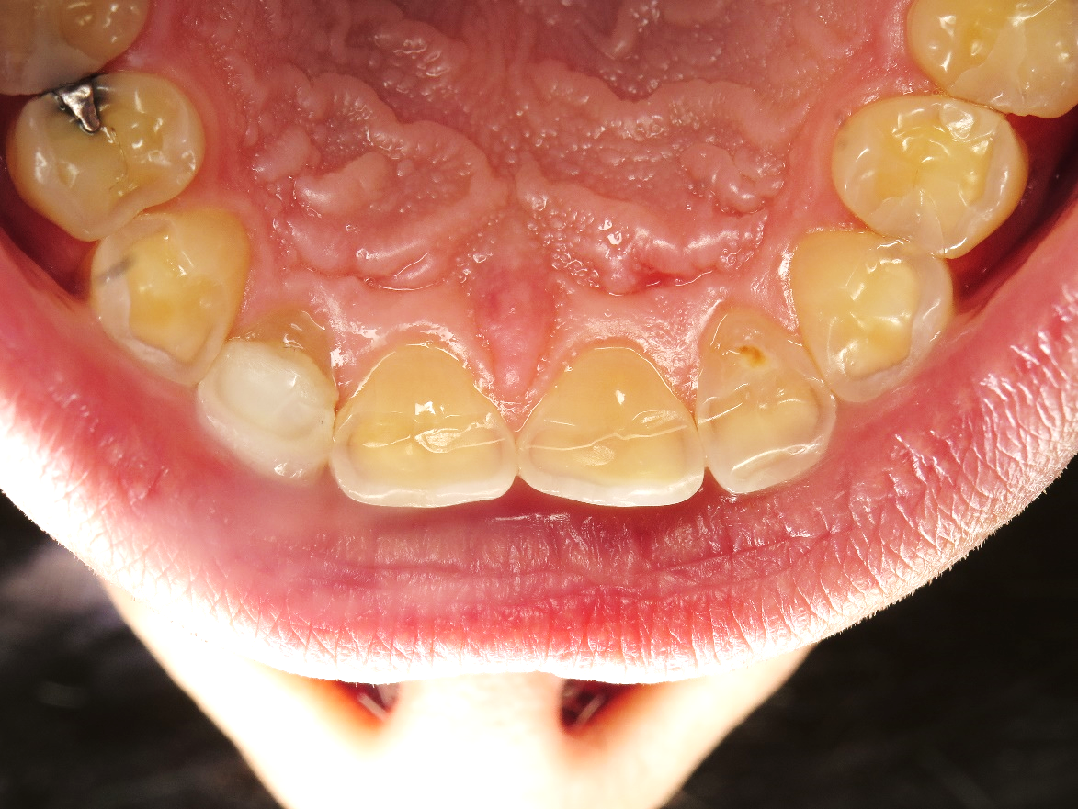

Fig 67 is a photo of the lingual surfaces of the maxillary anterior teeth. The erosion extends to the free gingival margins, wear facets from contact with mandibular incisors is also present. The thinning of the maxillary incisors cause sensitivity due to dentin exposure and create esthetic and restorative problems for the clinician.

With the loss of tooth structure, a possible loss of vertical is possible, also the loss of vertical could have led to continued eruption of the remaining teeth. Evaluation of closed speaking space shows a possible loss of VDO, but we do not know until we try and open the vertical. An orthotic was made to open the VDO and check the long term ability of the patient to tolerate a change in VDO. The patient wore the orthotic for several months with no problems. The authors felt we could move the patient into provisionals at an increased VDO to further evaluate the changes.
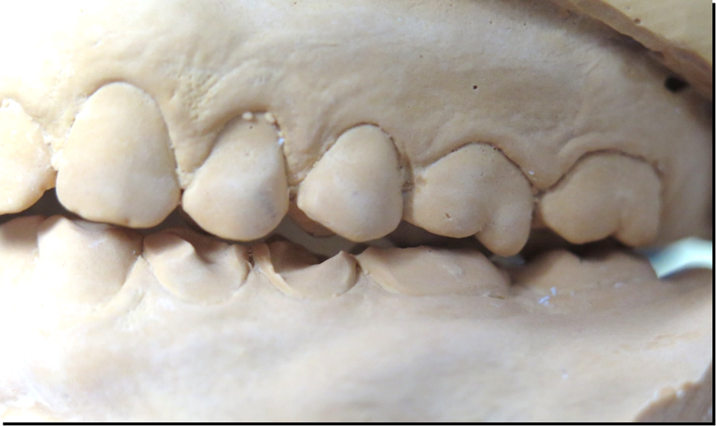
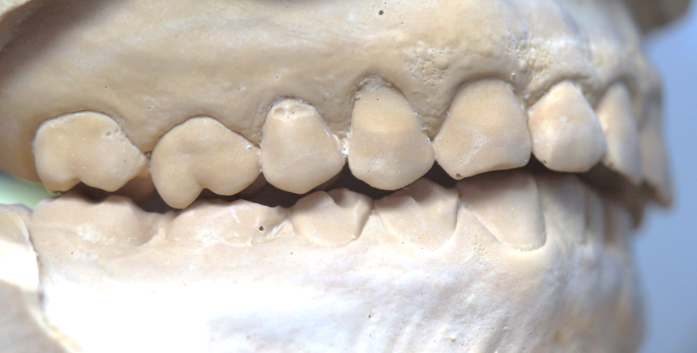
Fig 68 and 68 are photos of the casts after mounting. You can see the loss of tooth structure down to the free gingival margins on the mandibular posterior teeth. The super eruption of the maxillary first molars is demonstrated by the distal cusp of the first molars rotating downward. Restoring only one arch is not practical as the restoring dentist cannot establish a good plane of occlusion.

Impressions were made and the casts mounted. Changes in the horizontal plane are noted in the maxillary first molars as the distal cusps are moved down. An ideal wax up was completed which opened the VDO about 1.5mm at the incisal edges. The Maxillary anterior teeth were lengthened from 8.0mm to 10.5mm to reflect a more normal tooth length. The teeth were prepared for crowns and the provisionals were made indirectly. This allowed for long term wear of the provisionals, and allowed for the patient to floss and keep the provisional restorations clean.
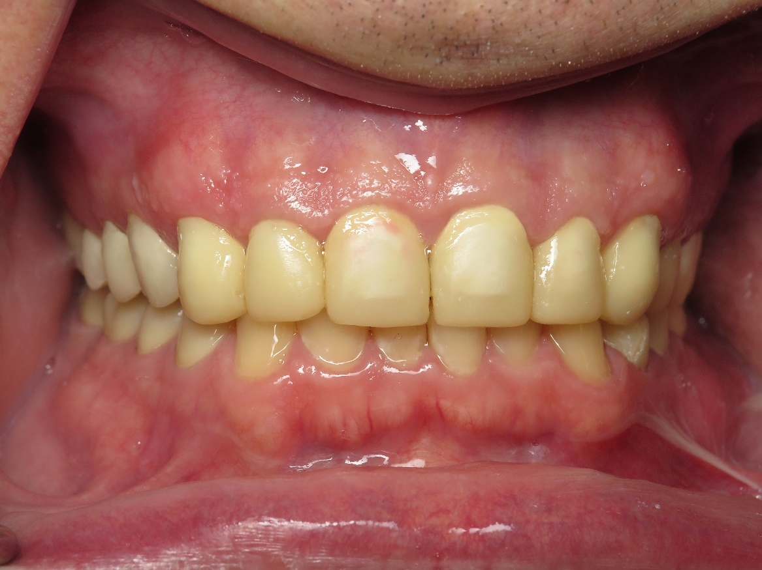
Fig 69 shows the indirect provisionals in place. The incisal edge length has been increased to the normal average length for central incisors. Normal contours have been restored. The patient can wear the provisionals for several months is necessary to insure both comfort and esthetics are correct for the patient.

Because of the severe loss of tooth structure, retention and crowns preparations were challenging. The use grooves and boxes give the severely eroded teeth better resistance and retention form.
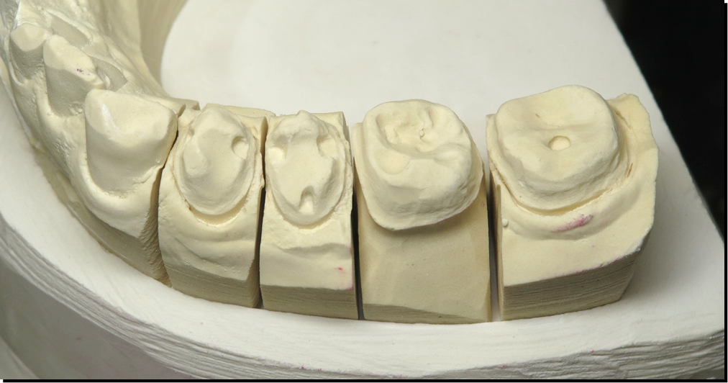

Fig 70 shows the preparations for the new lithium disilicate crowns. Note the boxes and grooves that are used to aid in the retention of the crowns. Due to the erosion many of the teeth had lost a significant amount of tooth structure and the boxes and grooves aid in the retention.

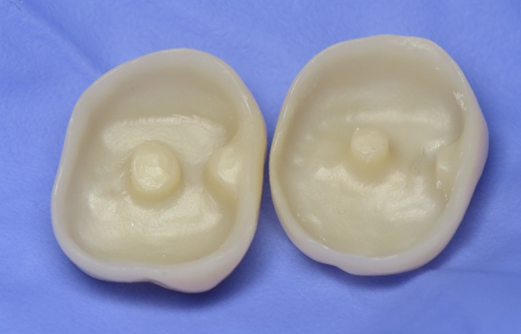

Fig 71 shows the intaglio surfaces of the new lithium disilicate crowns. These are pressed rather than milled to insure a good reproduction of the grooves and boxes.

The boxes and grooves are part of the intaglio surface of the individual crowns. These are eMax crowns which are pressed. Pressing the eMax give a better result than milling for grooves and boxes. The eMax can then be bonded to the tooth to aid in retention of the crown.
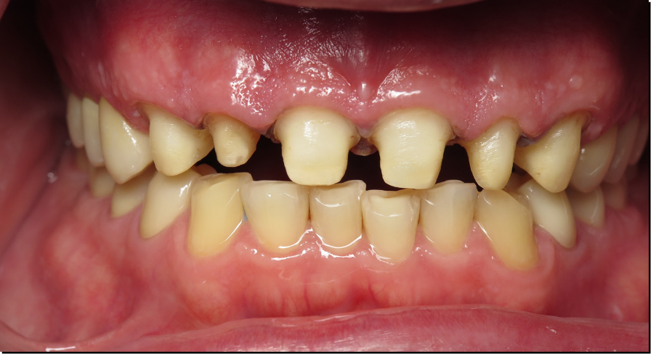

Fig 72 After the insertion of the posterior teeth, the maxillary anteriors are impressed. The provisionals will provide information to the dental lab on the length of the incisors, and the lingual contours which have been perfected in the provisionals.
The first author prefers to complete the posterior teeth first, the indirect methyl methacrylate provisionals hold up well and preserve the VDO as newly established. Now the anterior teeth can be completed. Using the provisionals as a guide, the provisionals are duplicated in an alginate impression, and used as a template for tooth morphology and anterior guidance. By using the provisionals in this way, we can be ensured of success for our final restorations. The mandibular anteriors showed minimal erosion and were not restored.
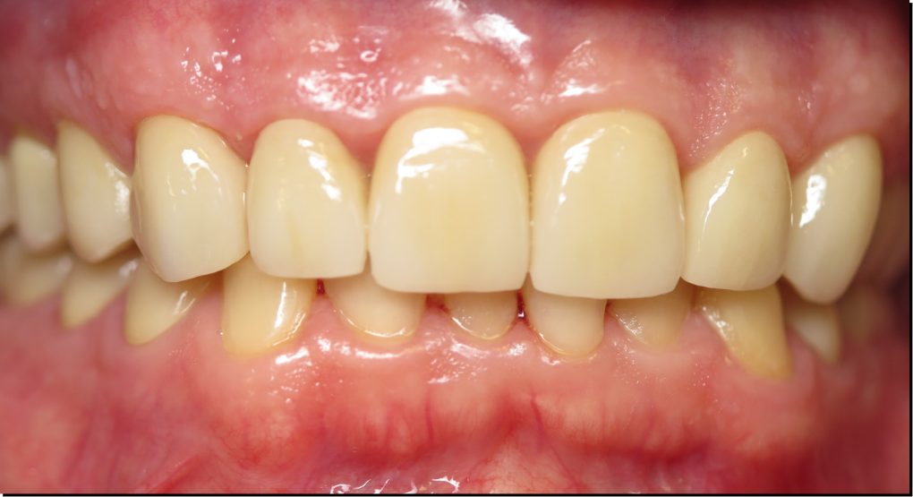

Fig 73 shows the final result for the case. All restorations are lithium disilicate and were bonded into place. The vertical has been increased by 1.5mm at the anterior teeth. Increasing the vertical has allowed the clinician more space for the new restorations, and better esthetics for the patient.
.

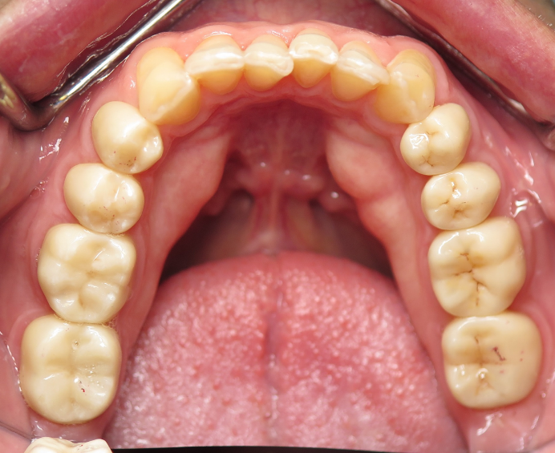
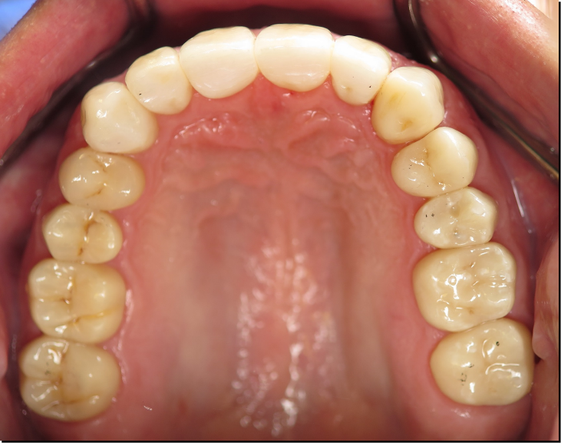
Fig 74 A successful case with the VDO opened 1.5 mm measured at the incisal edges. Shading porcelain was removed from the lingual of the maxillary anteriors and the eMax polished to minimize wear. Shading porcelains is normally feldspathic porcelain and can cause wear to the opposing dentition. The mandibular incisors were not restored.
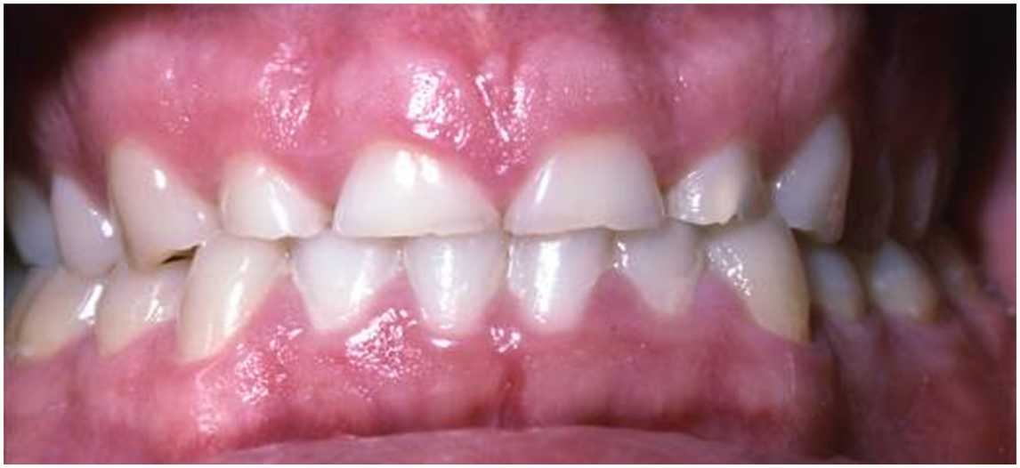
Combining the use of crown lengthening and change of vertical dimension of occlusion for the restoration of eroded teeth.

Fig 75 Photo is a 36 year old male. A combination of erosion from gastric reflux and bruxism has reduced the length of the anterior teeth.

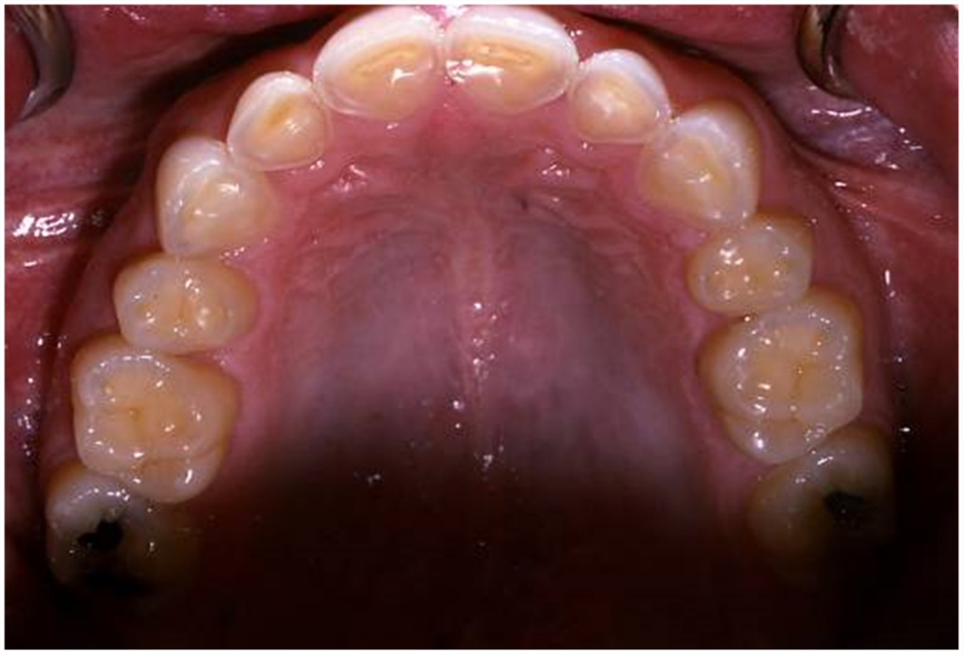

Fig 76 shows an occlusal photo of our patient. Loss of tooth structure is noted for the maxillary anterior teeth, but the posteriors have minimal tooth structure loss. As the stomach contents are moved out of the mouth, the teeth most involved are always the lingual surfaces of the maxillary anteriors.
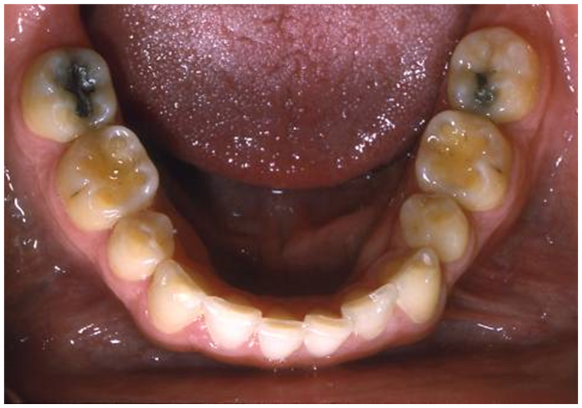
Occlusal view reveals little tooth loss in the first and second molars, yet significant tooth loss in the maxillary incisors. Note the loss of tooth structure down the free gingival margin. There is no contact between the mandibular incisors and the lingual of the maxillary incisors at the gingival margin. This can be seen in both bulimic patients and gastric reflux patients as the stomach contents hit the linguals on the way out. This presents a difficult scenario for the restoring dentist as there is little loss of VDO as there is little to no loss of tooth structure on the molars.
.
Fig 77 Mandibular occlusal view shows loss of tooth structure on the first molars, but little loss of tooth structure on the rest of the teeth. Note the first bicuspids have been removed. The first molars have cupping which is diagnostic of erosion
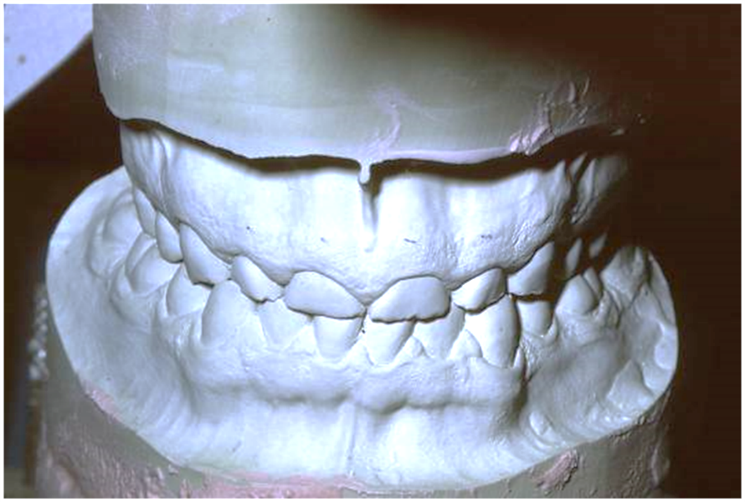

Fig 78 is the max and man casts for our patient. Always a first step is the mounting of the casts in a centric relation position. The use of a face bow will give the clinician the axis of rotation to aid the clinician in the restoration of the teeth with a possible increase in the vertical dimension of occlusion.
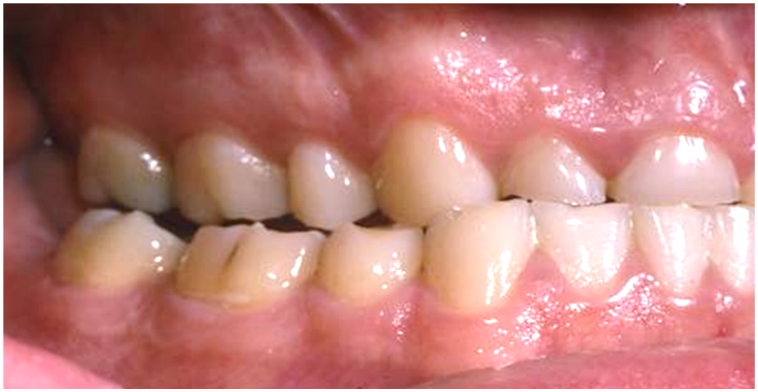

Fig 79 shows the patient’s right side, the loss of the length of the cuspid has allowed the patient to contact on all posterior teeth in lateral and protrusive movements. Parafunctional movements have accelerated the loss of tooth structure.

The patient is in a bilateral balanced occlusion, contributing to wear and loss of tooth structure. The maxillary and mandibular casts were mounted in a CR position. There were no interferences from centric relation to maximum intercuspation. Measuring on the cast, to make a 10.5mm anterior tooth, an excessive amount of bone would have to be removed. A decision was made to attempt to do both a crown lengthening and open the VDO by 2.5mm.
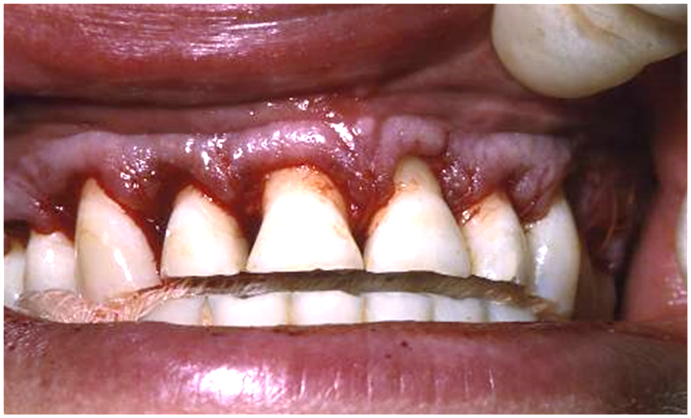

Fig 80 immediately following the crown lengthening procedure. A problem with crown lengthening is the narrow root structure which is not as wide as the cervical of a normal tooth.
A crown lengthening was completed, providing 4mm of additional length to the anterior teeth. 4 months of healing was allowed prior to more work. New alginate impressions were made and mounted. The VDO was opened 2.5mm at the incisal edge to allow better esthetics.
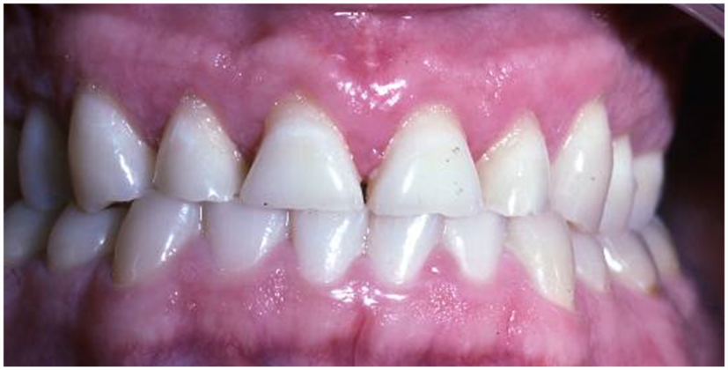
Fig 81 shows the anteriors after 4 months of healing. The keratinized tissues have now reorganized and healing is complete.
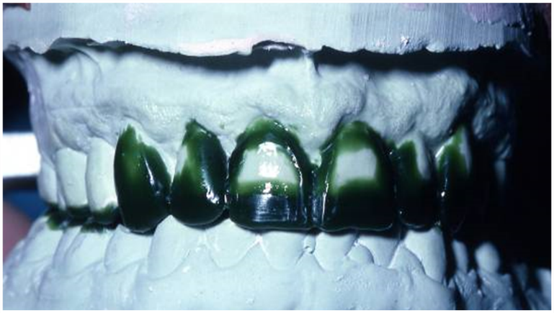

Fig 82 new alginate impressions are made, the casts mounted, and a wax up to increase the VDO on the posterior is completed, and a wax up of the maxillary anteriors is completed to provide desired esthetics.

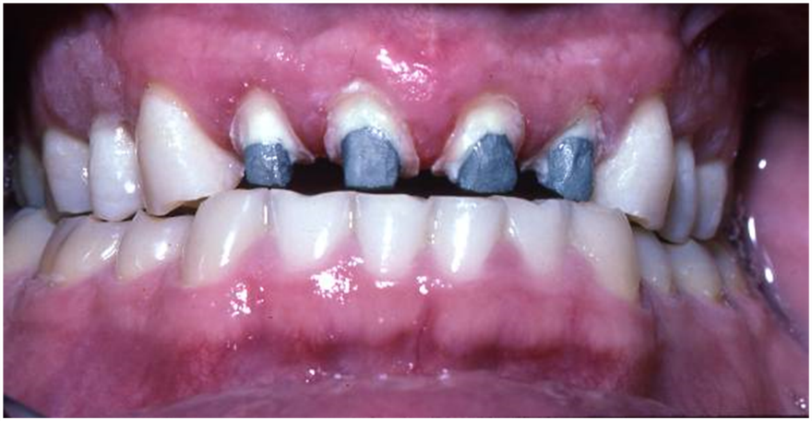
Fig 82 reflects the desired 10.5mm length of the central incisors change for esthetics. A combination of crown lengthening and VDO change will provide the esthetic desires. The wax up was duplicated, the teeth prepared, and indirect provisionals were made. There was not sufficient tooth structure remaining for retention of the maxillary anteriors, the lingual of the anteriors was very thin and any attempt to prep the teeth would result in pulpal exposure. A decision was made to do prophylactic endo on 7-10, followed by cast post and cores.

Fig 83 Cast post and cores inserted now provide excellent retention for the new crowns.
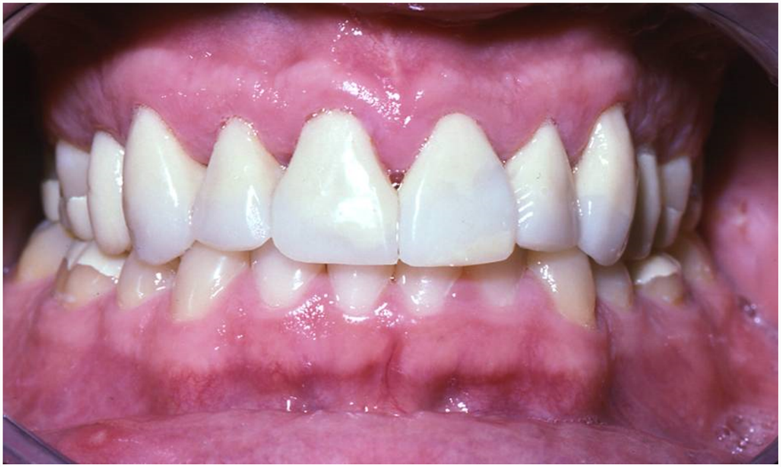

Fig 84 Indirect provisionals were made to increase the VDO and reestablish anterior esthetics.
Provisionals were made indirectly, and inserted providing the patient with and increased VDO of 2.5mm measured at the incisal edge.
Making provisionals indirectly gives the clinician the ability to evaluate the contour of each individual crown, allows the patient to properly clean the provisionals, and allows a trial run to evaluate esthetics and function. With a few days the patient began to complain of muscle pain and tenderness. The VDO was decreased by 0.5mm and the patient was allowed to return home to evaluate again the VDO change. The patient wore the provisionals for 4 weeks without complaint. It was felt that we could proceed with the final restorations. The provisionals were removed, cleaned, impressions made and the provisionals reinserted.
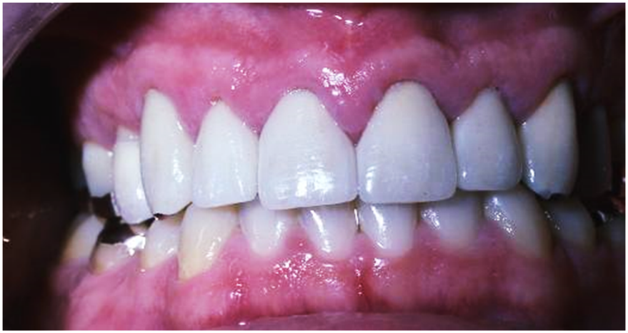

Fig 85 shows the successful restoration of the erosion and bruxism patient combining crown lengthening and an increase in VDO to restore the patient to function and esthetics. The patient was restored using PFM crowns and partial veneer gold crowns and gold onlays.
The combination of crown lengthening and change of VDO enabled the first author to restore this patient to optimum esthetics and function.
Conclusions
A wide range of treatment options exist when considering the restoration of the worn dentition, ranging from the more conventional fixed and removable prosthodontic approach to some of the newer, less invasive and minimal preparation adhesive techniques now available to the dental surgeon. While a number of the minimal preparation adhesive methods would appear to offer significant advantages over more traditional measures, only time and careful clinical evaluation will dictate whether these become the accepted routine treatment patterns of tomorrow.

References
- Steele JG, Walls AW, Ayatollahi SM, Murray JJ (1996) Major clinical findings from a dental survey of elderly people in three different English communities. Br Dent J 180:17-23.
- Nunn J, Shaw L, Smith A (1996) Tooth wear - dental erosion. Br Dent J 180:349-52.
- Nunn J, Gordon P, Morris A, Pine C, Walker A (2003) Dental erosion – changing prevalence? A review of British national childrens’ surveys. Int J Paed Dent 13:98-105.
- Van’t Spijker A, Kreulen C, Bartlett D (2009) Prevalence of toothwear in adults. Int J Prosthodont 22:35-42.
- Lussi A, Hellwig G, Zero D, Jaeggi T (2006) Erosive tooth wear: diagnosis, risk factors and prevalence Am J Dent 19:319-325.
- Mehta S, Banerji S, Millar B, Suarez-Feito J (2012a) Current concepts on the management of tooth wear: part 1. Assessment, treatment planning and strategies for the prevention and the passive management of tooth wear. Br Dent J 212: 17-27.
- Williams DR (1987) A rationale for the management of advanced tooth wear (ATW). J Oral Rehabil 14:77-89.
- Smith BG, Bartlett DW, Robb ND (1997) The prevalence, etiology and management of tooth wear in the United Kingdom. J Prosthet Dent 78:367-72.
- Schwartz NL, Whitsett LD, Berry TG, Stewart JL (1970) Unserviceable crowns and fixed partial dentures: lifespan and causes for loss of serviceability. J Am Dent Assoc 81:139-401.
- Walton IN, Gardner FM, Agar JR (1986) A survey of crown and fixed partial denture failures. Length of service and reasons for replacement. J Prosthet Dent 56:416-21.
- Tan K, Pjetursson BE, Lang NP (2004) A systematic review of the survival and complication rates of fixed partial dentures (FPDs) after an observation period of at least 5 years. Clin Oral Implants Res 15:654-666.
- Fyffe HE (1992) Provision of crowns in Scotland - a ten year longitudinal study. Comm Dent Health 9:159-64.
- Berry DC, Poole DFG (1976) Attrition: possible mechanisms of compensation. J Oral Rehabil 3:201-6.
- Ricketts NJ, Smith BGN (1993) Minor axial tooth movement in preparation for fixed prostheses. Eur J Prosthodont Restor Dent 1:145-9.
- Briggs P, Bishop K (1997) Fixed restorations in the treatment of tooth wear. Eur J Prosthodont Restor Dent 5:175-80.
- Talbot T, Briggs P, Gibson M (1993) Crown lengthening: a clinical review. Dent Update 20:301-306.
- Sara A. Alfadda, BDS, MSc, PhDa A conservative and reversible approach for restoring worn teeth:A clinical report. J Prosthet Dent 2014;112:18-21)
- Toolson LB, Taylor TD (1989) A 10-year report of a longitudinal recall of overdenture patients. J Prosthet Dent 62:179-81.
- Ettinger RL, Jakobsen J (1997) Denture treatment needs of an overdenture population. Int J Prosthodont 10:355-65.
- Buonocore MG (1955) A simple method of increasing the adhesion of acrylic filling materials to enamel surfaces. J Dent Res 34:849-53.
- Donovan et al. J Esthet Rest Dent 2004; 16: 194-204)
- Hansen PA, West L: Allergic Reaction Following Insertion of a Pd-Cu-Au Fixed Partial Denture: A Clinical Report. Journal of Prosthodontics 6:144 1997.
- Shubba, Sanyal, Patil, Estimating Ni, Cr, Co, and Mo release from 3 dental casting alloys in saliva and blood at 6 and 12 months by using inductively coupled plasma mass spectroscopy J Prosthet Dent 2024: 132: 402-207.
- Personnal Communication, Darryl Withrow, Glidewell Dental Lab.
- Denry I, Holloway J. Ceramics for dental applications: a review Materials 2010;3:351-68.
- Fasbinder DJ, Dennison JB, Heys D, Neiva G. A clinical evaluation of chairside lithium disilicate CAD/CAM crowns: a two year report J AM Dent Assoc 2010 141:10S-4S.
- Russel Wang A Comparison of Resins for Fabricating Provisional Fixed Restorations. International Journal of Prosthodontics 1989;2:2
- Hansen PA, Sigler, E, and Husemann, RH, Making Predictable Multiple Single Unit provisional Restorations. J Prost Dent 2009;102:260-263
- Juha Pihlaja 1, Ritva Näpänkangas 2, Ritva Kuoppala 2, Aune Raustia 2015 Nov;114(5):633-6. doi: 10.1016/j.prosdent.2015.05.008. Epub 2015 Sep 4.
29. Schuyler CH. Intraoral method of establishing maxillomandibular relation. J Am Dent Assoc, 1932;19:1013-1021.
30. Stuart C. In: Gnathologic Tooth Preparation. Quintessence Publishing Co., Chicago. 1985 p. 53.
31. Dawson P. Functional Occlusion From TMJ to Smile Design. 2007; Mosby Elesevier Publications, Philadelphia, Pa.
32. Lucia VO. Centric relation, theory and practice. J Prosthet Dent, 1960; 10:849.
33. Long JH Jr. Location of the terminal hinge axis by intraoral means. J Prosthet Dent 23:11;1970.
34. Fenlon MR, Woefel JB. Condylar position recorded using leaf gauges and specific closure forces. Int J Prosthodont 1993;6:402-408.
35. Rugh JD, Harlan J. Nocturnal bruxism and temporomandibular dis¬orders. In:Jankovic J. Tolosa E (eds). A Textbook of Occlusion. Chicago:Quintessence, 1988:249-261.
36. Posselt U. Studies in the mobility of the human mandible. Acta Odontol Scan, 1952; 10:19-35.
37. Hodge L, Mahan P. A study of mandibular movement from centric occlusion to maximum intercuspation. J Prosthet Dent, 1967; 18:19-30.
38. Rieder C. The prevalence and magnitude of mandibular displacement in a survey population. J Prosthet Dent 1978;39:324-329.
39. Neff, PA. TMJ Occlusion and Function. Georgetown University Publication 1975. P50.
40. Williamson EH, Anterior Guidance: Its effect on electromyographics activity of the temporal and masseter muscles. J Prosthet Dent 1983;49:816-21.
41. Spear, FM. Occlusal Considerations for Complex Restorative Therapy. In: McNeill C (ed). Science and Practice of Occlusion Chicago: Quintessence, 1997; 437-456.
42. Wilkinson T., Hansson TL, McNeill C, Marcel T. A comparison of the success of 24 hour occlusal splint therapy versus nocturnal occlusal splint therapy in reducing craniomandibular disorders. J Craniomandib Disord Facial Oral pain 1992;6:64-70.
43. Turner KA, Missirlian DM. Restoration of the extremely worn dentition. J Prosthet Dent, 1984; 52:467–474
44. Berry DC, Poole DF. Attrition: Possible mechanisms of compensation. J Oral Rehabil 2:1 1975.
45. Johansson A, Johansson A-K, Omar R, Carlsson G. Rehabilitation of the worn dentition. J Oral Rehab 2008; 35: 548-566.
46 Sailer et.al., Randomized controlled clinical trial of zirconia ceramic and metal ceramic fixed dental prostheses: Int J Prost Dec 2009.
47 Pelaez, J et.al., A four year prospective clinical evaluationof zirconia and metal ceramic posterior fixed dental prosthesis. Int J Prost 2012:24;451-458.
48 A study on the in vitro wear of the natural tooth structure by opposing zirconia or dental porcelain. J Adv Prosthodontics 2010;2:111-115.
49 Wear evaluation of the human enamel opposing different &-TZP dental ceramics and other porcelains. Journal of Dentistry 2012.
50. Mitov, G et.al., Wear behavior of dental Y-TZP ceramic against natural enamel after different finishing procedures. Dental Materials 2012 28;p909.

