kansas city
dental symposium
Sheraton Overland Park, 6100 College Blvd, Overland Park, KS
THURSDAY, SEPTEMBER 16, 5:30 to 8:00PM
Cocktail Reception for All Attendees & Exhibitors
Drinks, Hors d’oeuvres, Door Prizes, Free CE Class!

FRIDAY, SEPTEMBER 17, 8:00AM to 5:00PM

PRACTICE MANAGEMENT PRESENTATION

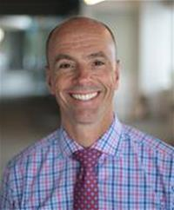
"The Four Keys to Master Treatment Acceptance"

Presented by Kirk Behrendt of ACT Dental
Appropriate for the Entire Dental Team
Bring your team to this incredibly valuable lecture to see the PROVEN ways patients are saying “YES” in the current economy. This high-energy lecture will give you and your team a simple treatment plan to start on Monday to change your practice immediately. Come to this seminar to see the 4 ways great dental teams are adapting to the ever-changing world and make these relationships “POWER-full” to keep treatment acceptance and production numbers up.
Upon completion of this course, attendees will:
· Learn the 4 step process behind a highly productive practice that gives patients more
confidence to say yes consistently.
· Be able to apply three easy changes to your schedule that can double your production in the
next few months.
· Learn the 6 best power phrases you could ever say to a patient to increase the new patient
flow in case acceptance percentage.
· See the critical steps to establishing and implementing an elegant handoff with patients.
· Learn how to remove the obstacles to help patients “pay in full” or “pay in full” to eliminate your
Accounts Receivable.
· See the 4 most powerful questions to ask a patient and how to use them.

CLINICAL PRESENTATION

MORNING LECTURE

"Cutting Edge Technology with Digital Design and Real World Cosmetic Dentistry: Faults, Failures, and Fixes"
Presented by Joyce Bassett, DDS

Failures in dentistry are frequently blamed on materials, but in reality, many times operator error is the culprit. This innovative and fast-paced course will focus on aesthetics that are BUILT TO LAST. Clear, concise, and systemized techniques will be presented to treat every aspect from simple to complex cases involving veneers, crowns and implant restorations. These protocols will increase profitability by preventing failures that occur day-to-day in your office. Cutting edge preparation techniques that will simplify difficult space management cases will be presented, along with how to handle shade challenges and when preparation modifications may be necessary. You will understand how to integrate flowable composite on the provisional and communicate the final patient approved shapes. State of the art digital smile design linking 3D prosthetic planning with fundamental principles and real-time communication that decreases dentist chair time and ceramist re-work. The relationship of form and function precludes treating anterior teeth as cosmetic challenges alone. Aesthetic and functional parameters of incisor position and morphology, dental facial treatment planning, determination of vertical dimension, and bite force management will be presented as components that allow comprehensive restorative treatment. Occlusal guidance must be understood so the final designs of the restoration can accommodate the intra-oral forces assuring longevity and predictability of the prosthesis.
Upon completion of this course, attendees will be able to:
• Integrate sound occlusal principles to create synergy between form and function
• Identify which adhesives and restorative materials work the best for maximum predictability and learn matricing techniques and bulkfill technology for mastering posterior composite.

AFTERNOON LAB (Additional Lab Fee: $75)

"Composite Artistry: Mastering Posterior & Anterior Techniques for Direct Composite and Creating Undetectable Restorations"

Presented by Joyce Bassett, DDS

Direct aesthetic restorations are the most requested performed procedures in any dental practice today. New advancements in resin and photo-polymerization technology allows us to simplify these procedures without compromising quality. A clinical update on adhesive technology will be presented. Dr. Bassett will clear the confusion of bonding agents and techniques ranging from incremental layering to bulk fill technology in the posterior. Techniques to create morphologically precise direct anterior and posterior composite restorations will be discussed and demonstrated. This course will train your eyes to see the different dimensions of color when evaluating an anterior tooth. You will then learn which opacities and thickness to use in each area to be reconstructed and make a fracture line disappear. Subsequently, your eye will see the reflective surfaces and facial anatomy and learn step by step finishing and polishing technique to mimic the contralateral tooth and create a morphologically precise undetectable restoration. Learn when and how to use pink composite to mimic gingiva.
Upon completion of this course, attendees will be able to:
• Train your eyes to see color, line angles, reflective surface, shape, and form in the adjacent tooth that is being replicated
• Learn how to achieve a predictable composite restoration following the stratification of opacities and achieve undetectable restorations
• Learn how to layer the different opacities of composite, opaquing, tinting, finishing and surface texture to create natural light reflection and make a fracture line disappear.

Many Exhibitors & Sponsors Participating! Come visit them and see what special deals they can offer!

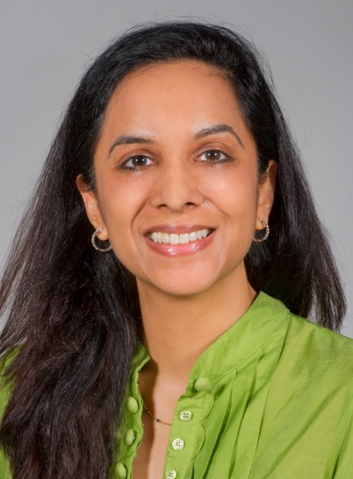
Additional Afternoon Lectures Include:

AFTERNOON LECTURE

"50 COMMON ORAL CONDITIONS--WHEN TO BIOPSY & WHY"
Presented by Aparna Naidu, DDS, MS
The speaker will present abnormal clinical and radiographic conditions that are most commonly seen in a general dental practice. The cases will be selected to cover a wide range of diagnoses. A review of differential diagnosis and discussion of each condition will offer an update of our understanding of each clinical entity.
Upon completion of this course, attendees will be able to:
•Improve recognition of the more common oral pathological conditions
•Assess clinical and radiographic features to develop an appropriate differential diagnosis
•Understand therapeutic management of common pathologic conditions and when a biopsy is required to arrive at a final diagnosis.
•Have increased insight into the cases discussed, including the diagnostic criteria, differential diagnoses and disease classification.
•Refine their approach to diagnosis of this group of lesions
•Be familiar with the management and/or treatment for each of these entities

AFTERNOON LECTURE
" White Collar, Cyber, & Medicaid Crime Affecting the Business of Dentistry"
Presented by Ed Brancart, Senior Assist, Attorney General
Ed Brancart is Senior Assistant Attorney General and Deputy Director of the Medicaid Fraud & Abuse Division of the Kansas Attorney General’s Office. His legal experience includes serving as Chief Deputy District Attorney in Wyandotte County, as the elected County Attorney in Ford County (Dodge City), and as a special assistant United States attorney. Mr. Brancart holds a law degree from Washburn University School of Law, and a Bachelor of Arts degree from Pittsburg State University. He is a past-president of the Kansas County and District Attorneys Association. In addition to prosecuting in municipal, state, and federal courts, he has litigated appeals in the Kansas Court of Appeals and the Kansas Supreme Court.

