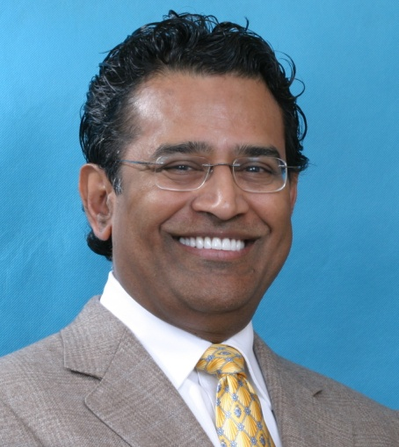
Occlusion/TMD Lecture & Workshop
Prabu Raman, DDS
October 11 & 12, 2019
Lecture on October 11th: 8:30 AM - 12:00 PM
Workshop on October 12th: 8:00 AM -12:00 PM
Lecture at: Adams Pointe Conference Center of Courtyard by Marriott
1400 NE Coronado Dr. • Blue Springs, MO 64014
Workshop location TBD.
Lecture cost: $120 for ADA-Member Dentist/$160 for Non-Members/$65 for Staff
Workshop cost: Dentists: $150/$50 for Staff
Register with Sam at gkcds@att.net/816.737.5353.

Dr. Raman teaches live patient and lecture courses on Aesthetics and TMD treatment. He served for 12 years as a Clinical Instructor & Featured speaker for the Las Vegas Institute of Advanced Dental Studies.

Dr. Raman has lectured on TMD treatment in Argentina, Australia, Canada, Germany, India, Italy, Japan, Russia and throughout the USA. He was selected by the ADA Council on Scientific Affairs as a TMD expert to participate in the Science Forum at the 2011 ADA annual meeting. He was also selected by the Journal of the California Dental Association to be an invited TMD expert author to contribute to its August 2014 TMD issue.

Dr. Raman has achieved Mastership status of the International College of Cranio Mandibular Orthopedics and Mastership of Las Vegas Institute of Advanced Dental Studies. He is also a Fellow of American College of Dentists and a Fellow of Pierre Fauchard Academy.

Dr. Raman served as President of the Missouri Dental Association (2016-17), Member of the ADA Council on Dental Education and Licensure (2013-17), Chair of ADA Recognition of Dental Specialties and Interest Areas in General Dentistry Committee (2015-17) and continues to serve as a member of the ADA House of Delegates. He is also the Vice-President of the International College of Cranio Mandibular Orthopedics (ICCMO), Past President of the International Association for Comprehensive Aesthetics (IACA), and past President of the Greater Kansas City Dental Society.

Dr. Raman’s Kansas City practice, The Raman Center for Advanced Dentistry, focuses exclusively on four areas of excellence, including: cranio cervical mandibular dysfunction/temporo mandibular dysfunction, aesthetic dentistry/complex restorative dentistry, neuro-muscular functional orthodontics, and sleep breathing disorders / oral appliance therapy.

Lecture: “TMJ” – What is it? How does it apply to everyday dentistry?
Attendees will learn from the perspective of a clinician who has exclusively devoted his practice to treating complex TMD / CCMD cases for 20 years, what exactly constitutes “TMJ”, Temporo Mandibular Dysfunction / Cranio Cervical Mandibular Dysfunction and how to recognize “asymptomatic” patients who may become symptomatic after routine restorative dental treatment or minor orthodontic treatment. It is recommended for dentists, dental hygienists and clinical dental assistants.

Upon completion of this course, attendees will have learned:
• A clear understanding of ”TMJ,” TMD / CCMD
• How to dispel the “TMJ” myths we may have learned as facts
• How to recognize the signs and symptoms of TMD…probably not what you learned in dental school
• How to inform patients before you perform even routine care
• How to implement strategies in daily practice to lessen occurrence of TMD
• How to avoid practices that could precipitate TMD symptoms
• About the connection between TMD and Obstructive Sleep Apnea

TMD Examination and Jaw Discrepancy Diagnosis - “The Bite-Taking Workshop”
Pre-requisites: 1. Attendance of Friday morning lecture course 2. “TMJ questionnaire” completed for the ‘patient’ (doctor or a team member) 3. Trimmed maxillary and mandibular study models of the ‘patient’

This workshop covers the practical application of the PNMD principles discussed in the introductory lecture on Friday morning, to actually treat TMD cases at a basic level. It consists of lecture plus hands-on demonstrations on volunteers, as well as give attending doctors hands-on experience in evaluation and diagnosis of TMD cases. This micro-residency format would prepare the dentists to apply the knowledge gained, back in their practices ‘Monday morning.’ Symptomatic or asymptomatic TMD patients needing quadrant restorative care, partial dentures and complete dentures could be treated more confidently with this learning experience. Physiologic NMD occlusal principles can provide a simple, reproducible bite conducive to health, aesthetics and restorative predictability and longevity.

Recommended for dentists and two clinical team members per dentist. It is highly recommended to bring your team to support and implement the techniques learned in the course.

Upon completion of this workshop, the attendee will be able to:
• Understand the important relationship of teeth, muscles and joints and its effect on facial structure and stomatognathic function.
• Perform a hands-on TMD examination
• Effectively diagnose and manage TMD patients
• Take a Physiologic NM bite for long term stability in restorative and TMD cases

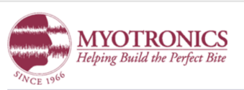
Program partially sponsored by: Kettenbach & Myotronics.

