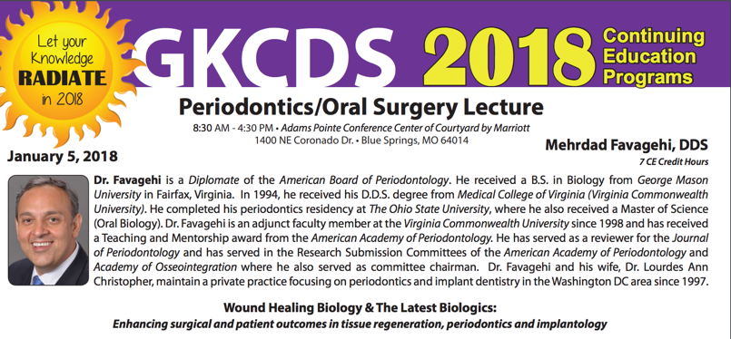

Greater Kansas City Dental Society

Wound Healing Biology & The Latest Biologics: Enhancing surgical and patient outcomes in tissue regeneration, periodontics and implantology.

Mehrdad Favagehi, DDS, MS, Diplomate- American Board of Periodontology
January 5, 2018

Advances in biology have enhanced our ability to manage wound healing and tissue regeneration. These advances have opened the door to remarkable outcomes in patient care. Several growth factors that enhance healing are now available to the dental practitioner as biologic agents.

A review of the latest in the core science of biology, inflammation and wound healing will be provided. Once the clinician is updated with the current knowledge in the core sciences, that knowledge can be used as a guiding compass to navigate through the latest materials, techniques and trends in biologic products, lasers, tissue regeneration, implantology and periodontal management of patients from a biologic point of view. Practical applications and surgical techniques will be shown for socket preservation, hard/soft tissue grafting involving periodontal regeneration, implantology and management of peri-implantitis.

Upon completion of this course, attendees will receive a:

• Review and update regarding the biology of wound healing and bone remodeling

• Review of the different commercial and non-commercial biologic modifiers which enhance wound healing and surgical outcome

• An update about new trends to enhance surgical and patient outcomes using biologics, lasers, periodontology and implantology

• An understanding of modern biology and wound healing in different aspects of patient care from case selection and diagnosis to treatment and maintenance

• Demonstration of the latest trends in techniques and materials used for socket preservation, implant surgery, gingival grafting, and management of peri-implantitis through actual cases which will be presented during the presentation.

COURSE OUTLINE:

- Introduction: Commercial interests in implant dentistry have shifted our focus from the patient to implant brands. The case will be made that we need to refocus on the patient because the same technique and material often results in significantly different outcomes. This variability can in part be explained by differences in healing, inflammation and bone maintenance displayed by different patients.
- We need to know about wound healing to enhance healing: To optimize surgical outcomes, we need to look at inflammation which orchestrates wound healing.
- Looking at inflammation, parallels will be drawn between periodontitis and implant failures/peri-implantitis.
- Review of factors that delay healing: Smoking, diabetes, STRESS.
- Stress and Wound Healing:
When stress in perceived by the brain, the stress hormone: cortisol is produced. Cortisol is the major hormone which orchestrates the body’s response to psychological stress. Cortisol (stress hormone) is anti-inflammatory. The major pro-inflammatory cytokine is Interleukin-1 (IL-1). It plays a central role in inflammation and wound healing. By depressing IL-1 expression, steroids such as cortisol depress the inflammatory response and wound healing. Research in this area will be presented to convince the attendees to look at stress as a risk factor for poor wound healing and poor surgical outcomes.
- Review of bone healing after implant surgery. A 12 minute video will be shown which highlights the different inflammatory cytokines (interleukins/growth factors) that orchestrate healing and ossointegration.
- Bone biology and bone turnover, and remodeling will be reviewed. Videos.
- Bone Grafting/ Guided Tissue Regeneration (GTR) will be discussed in periodontal regenerative surgery, socket grafting and site development for implants
- Biologics: Commercially Available biologics will be reviewed (rh-PDGF-BB ; GEM21S), (rh-BMP-2 ; Infuse), (Enamel Matrix Protein, EMDOGAIN).
- Biologics: From whole Blood. PRP: Platelet Rich Plasma and L-PRF Leukocyte rich Platelet Rich Fibrin will be discussed.
- Socket grafting/socket preservation, immediate implant Placement.
The ideal techniques for immediate implant placement will be reviewed.
Risk management in immediate implant placement vs. delayed implant placement will be reviewed.
- Ridge augmentation/sinus lift (lateral wall approach).

- Sinus lift (vertical approach), Osseodensification will be reviewed. Use of Densah burs will be reviewed.

- Peri-implantitis Etiology, diagnosis and treatment

- Zero Bone loss Concept around dental implants will be reviewed.

- Periodontal treatment vs. implants: When to extract teeth.

- Periodontal prognosis.

- Lasers used in Oral, implant and Periodontal Surgery

- Crown lengthening: Flap or flapless, laser, piezo-surgery.

- Soft tissue grafting to treat gingival recession will be reviewed.

