Informing “Informed” Consent- An Ethical Imperative

Theresa S. Gonzales, DMD, MS, MSS
Professor, Department of Stomatology
The Medical University of South Carolina
Charleston, South Carolina

As a hospital based, oral and maxillofacial pathologist for essentially three decades, I have had the opportunity to regularly review a number of “informed consent” documents in patient healthcare records. The basis for informed consent is derived from common law, emphasizing that “every human being of adult years and sound mind has a right to determine what shall be done with his own body.” There is something about a diagnosis of cancer that obviates the necessity of the consent process. Not surprisingly, cancer patients often feel vulnerable and powerless against their disease and subsequent the biopsy confirmation of their disease, a bewildering array of therapies will be made available to them. These discussions often occur in the context of a formalized Tumor Board replete with a seemingly endless barrage of medical terminology. Patients scarcely have time to process the implications of their diagnosis before they are asked to provide consent for treatment of their disease. Furthermore, these patients seem to instinctively understand that they will likely need separate consents for each of the proposed therapies to include: surgery, chemotherapy and radiation therapy. As patients sign the consent forms, they acknowledge that they are signing legal documents that allow the doctors to proceed with the proposed treatment plans. In this way, the patient is giving expressed consent to the continue. This process of obtaining informed consent is exceedingly common in the ambulatory outpatient practice of dentistry. As healthcare providers, we have long known that effective communication and thorough patient education are the best allies for encouraging patient collaboration and gaining patient cooperation in selecting and adhering to a treatment plan. In this article we will review the statutory requirements for informed consent as well as informed refusal and briefly review the options available to those patient cohorts who cannot give consent due to age, infirmity or both.
At its best, informed consent is a process of communication that empowers a patient to make voluntary decisions about accepting or declining care. Informed consent has both ethical and legal implications in clinical practice. Generally speaking, consent should be obtained for therapeutic and diagnostic procedures where disclosure of significant healthcare information, including major risks involved, would assist a patient in making an intelligent decision whether to undergo the proposed procedure. For this consent to be valid- it must be appropriately “informed”. In short, clinicians do not get informed consent rather- patients give informed consent. This is a difference with distinction. First and foremost, the consent must be voluntary and the individual patient giving the consent must be competent to do so. There are many situations in which an individual simply cannot give consent. These include children under the age of majority; individuals with cognitive impairment; most emergency situations and in patients with varying levels of consciousness. The patient's consent is generally presumed in emergency situations. This can also occur when the patient is unconscious or incompetent and no surrogate decision maker is available and the immediate interventions will prevent death or disability. According to O’Neill, another “limitation of informed consent emerges when people with adequate competence to consent are under duress or constraint, so less able to refuse others' demands. Prisoners, the vulnerable, and dependent often have ordinary capacities to consent but cannot refuse, so undermining any ‘consent’ they offer.” There are also cultural considerations, in some cultures patients traditionally defer the decision making to a loved one and the consent is obtained in lieu of the patient. For children or others who are unable to make the decision for themselves, the parent or legal guardian is legally responsible for getting the information, making the decision, and signing the consent form. Most states have a separate provision for those individuals who can no longer make decisions for themselves and this is managed through a durable power of attorney for health care, a court appointed proxy or through the provisions of a state family agency act. These processes vary from state to state and it is wise to be knowledgeable about specifics for the state in which you practice.
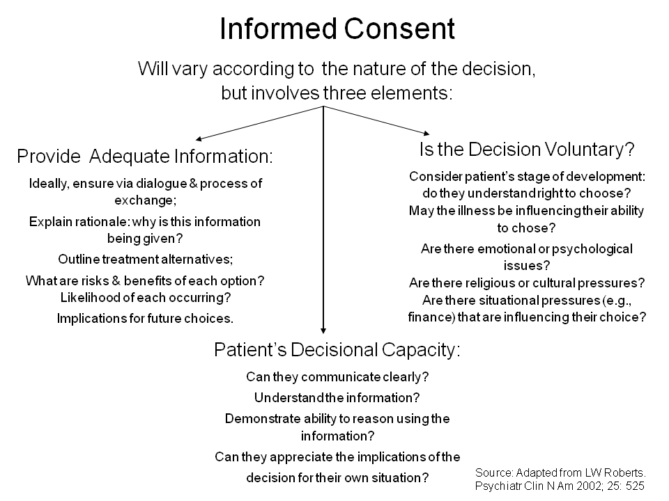
Informed consent is intended to shift the ethical paradigm for decision-making away from doctor-centered models to more patient-centered approaches. The ethics of informed consent center on patient autonomy and their right of self-determination. In order to exercise the right of self-determination, the patient must fully understand their diagnosis, prognosis, proposed treatment plan, alternative treatment options to include the option of no therapy. This information must be provided in a language that is comprehensible to the patient. It is the providers responsibility to obtain the informed consent of the patient, and to discuss sufficient information to enable the patient to decide whether to submit to treatment. The provider is responsible for informing the patient and completing the necessary documentation for the record. In the event where the patient refuses treatment, patient’s informed refusal of recommended diagnostic and therapeutic interventions, particularly when the decisions have systemic implications should also be documented. Generally speaking, consent should be obtained for therapeutic and diagnostic procedures where disclosure of significant healthcare information, including major risks involved, would assist a patient in making an intelligent decision whether to undergo the proposed procedure. The consent process should be performed by the practitioner who will perform the procedure, and the consent is valid only for that specific practitioner to perform the procedure.
Requirements for Informed Consent
The patient’s diagnosis
The nature and purpose of recommended interventions
The burdens, risks, and expected benefits of all options, including the implications of forgoing treatment
The anticipated costs of proposed treatment

Requirements for Informed Refusal
• The patient’s diagnosis
• Treatment options and the treatment plan the patient elected (if any), as well as risks and benefits associated with each
• Acknowledgement that the patient refused or terminated treatment

Requirements for Documentation in the Dental Record
A patient's consent should be documented with sufficient clarity and detail so as to satisfy the reader that the patient was given and understood the information and the implications. Documentation should include the patient's diagnosis, the recommended treatment, the outcomes that might occur if the condition isn't treated, and all patient education efforts.
Such documentation should include:
- A statement that the information provided above was imparted to the patient
- A specific listing of some of the major material risks that were disclosed including infection, hemorrhage and the potential for nerve injury
- The date the patient expressly gave his/her consent
- The date the documentation was recorded (if different than the date of consent)
- Signature of the provider disclosing the information and obtaining consent
- Signature of the patient

In summary, the process of obtaining and documenting informed consent and informed refusal is far from a perfect science and over the past several decades, the procedure has undergone many administrative improvements to address these realized limitations. However, in our efforts to streamline the logistics of consent, we may have diluted the original intent of the consent process. The intent was not and is not merely to ensure statutory compliance within our respective practice jurisdictions. The intent is to better inform patients about their diseases and their therapeutic options in the evidence-based management of their conditions. According to the Joint Commission, “the process of obtaining informed consent is an essential aspect of patient-centered care and remains central to patient safety.” As a practice community we acknowledge that our patients have a right to be informed about a proposed treatment and determine whether or not they wish to move forward with the proposed treatment. Communication skills, compassion and confidentiality are essential to build the trust dividend between provider and patient that informs the process of informed consent. The single most important feature of the consent process is the deliberate effort to “inform”.

References

Schloendorff v. Society of New York Hospital, 105 N.E. 92 (1914)
O’Neill O . Some limits of informed consent. J Med Ethics2003;29:1, 5. Appelbaum PS. Assessment of patient’s competence to consent to treatment. New England Journal of Medicine. 2007; 357: 1834-1840. Childress JF. Who Should Decide? Paternalism in HealthCare. New York, NY: Oxford University Press; 1982 Faden, Ruth R.; Beauchamp, Tom L.; and King, Nancy M. P. 1986. A History and Theory of Informed Consent. New York: Oxford University Press. Germany (Territory Under Allied Occupation, 1945–1955: U.S. Zone) Military Tribunals. 1947 "Permissible Military Experiments." In vol. 2 of Trials of War Criminals Before Nuremberg Tribunals Under Control Law No. 10, pp. 181–184. Washington, D.C.: U.S. Government Printing Office. Gillon R. Medical ethics: Four principles plus attention to scope. BMJ. 1994; 309:184–8. [PMC free article] [PubMed] [Google Scholar] New York University. Post-Graduate School. 1972. Proceedings of the Symposium on Ethical Issues in Human Experimentation: The Case of Willowbrook State Hospital Research, May 4. New York: New York University Medical Center.
The Joint Commission Quick Safety Issue 21, February 2016 Page | 2

